Cedars Primary School
Reception Long Term Plan 2026-2027



 | Autumn 1 | Autumn 2 | Spring 1 | Spring 2 | Summer 1 | Summer 2
Topic | Me and My World | Hip, Hip, Hooray | Hot and Cold | Spring time | The Jolly Postman and his Friends | Sunshine and Sunflowers
Core Texts | 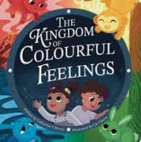  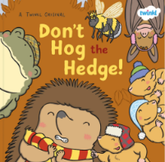  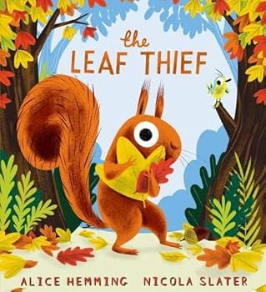  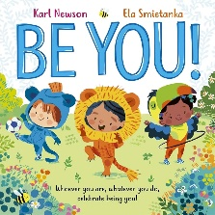 | 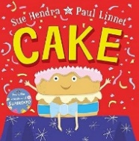  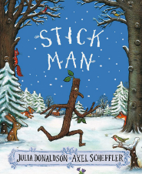  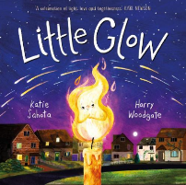  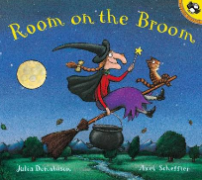  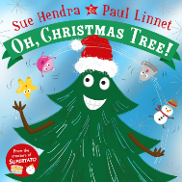 | 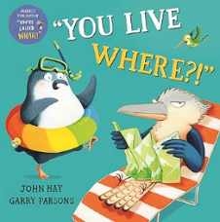  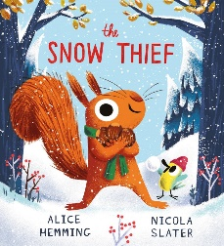  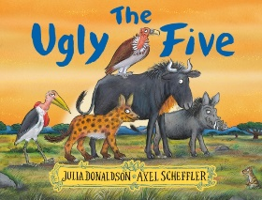 | 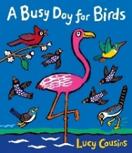  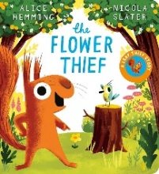  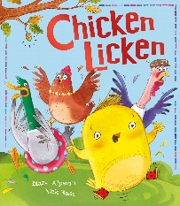 | 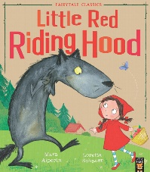  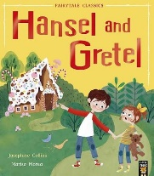  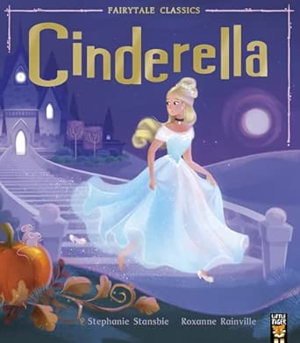  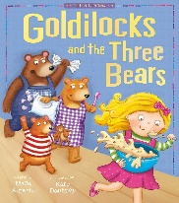 | 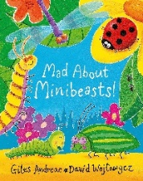  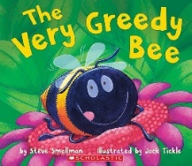  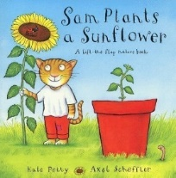  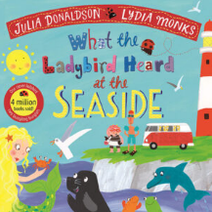
Recommended Reads | When we Grow up!  Where’s my Teddy? | ‘Not that pet!’  The Gruffalo | Pets  My day with the Panye | The Lost Property Office Owl Babies | Little Elephant  Iguanas love Bananas | Walking with my Iguana  Mr Gumpy’s Outings
Talk through Stories | Hugless Douglas  The Rainbow Fish | Owl Babies  Room on the Broom | The Slightly Annoying Elephant  There’s a snake in my school | Billy and the Beast  Billy and the Dragon | Six Dinner Sid  Can’t you Sleep, Little Bear? | The Extraordinary Gardener  Ruby’s Worry
Songs and Rhymes | Twinkle, twinkle Little Star  Humpy Dumpty  Zoom, zoom, zoom | Row, row, row your boat  Tiny turtle  The grand old duke of York | Hickery, dickery dock  Mary had a little lamb  Jack and Jill | I’m a little tea pot  Hey diddle diddle  Wheels on the bus | Hot cross buns  Little Bo Peep  Miss Polly had a dolly | Mary, Mary quite contrary  5 little ducks  There’s a worm at the bottom of the garden
Wow Moments | Starting School  Teddy Bears Picnic  Autumn Scavenger Hunt | Class Birthday party  Father Christmas visit | The Big Bird Watch RSPB | Litter picking in our local area | Post a letter home  Princess and Princes Party Day | Minibeast Bug Ball Party Day  End of Year Trip
Festivals and Celebrations |  | Diwali  Halloween  Remembrance Day  Bonfire Night  Christmas | Chinese New Year  Valentines Day  Pancake Day | Easter  Eid  St. Georges Day |  | Eid

Autumn 1 | Autumn 2 | Spring 1 | Spring 2 | Summer 1 | Summer 2
Me and My World | Hip, Hip, Hooray! | Hot and Cold | Spring time | The Jolly Postman and his Friends | Sunshine and Sunflowers
Characteristics of Effective Teaching and Learning: To learn well, children must approach opportunities with curiosity, energy and enthusiasm. Effective learning must be meaningful to a child, so that they are able to use what they have learned and apply it in new situations. These abilities and attitudes of strong learners will support them to learn well and make good progress in all the Areas of Learning and Development.
Playing and Exploring:  To guide their own thinking and actions by talking to themselves as they play. To bring their own interest and fascinations into the early years setting.  Active Learning:  To keep on trying when things are difficult. To begin to predict sequences because they know a routine.  Creating and Thinking Critically:  To take part in simple pretend play. To use pretend play to think beyond the ‘here and now’ and to understand perspective. |  | Playing and Exploring:  To recognise that their actions have an effect on the world, so they like to repeat them. To plan and think ahead about how they will play with objects.  Active Learning:  To begin to correct their own mistake. To participate in routines.  Creating and Thinking Critically:  To sort materials. To feel confident about coming up with their own ideas. To concentrate on achieving something that is important to themselves. |  | Playing and Exploring:  To make independent choices. To respond to new experiences when they are brought to the child’s attention.  Active Learning:  To show goal-directed behaviour.  Creating and Thinking Critically:  To solve real problems. To review their own progress as they try achieve a goal and for them to check how well they are doing. To make more links between their own ideas.

Autumn 1 | Autumn 2 | Spring 1 | Spring 2 | Summer 1 | Summer 2
Me and My World | Hip, Hip, Hooray! | Hot and Cold | Spring time | The Jolly Postman and his Friends | Sunshine and Sunflowers
Communication and Language: The development of children’s spoken language underpins all seven areas of learning and development. Children’s back-and-forth interactions from an early age form the foundations for language and cognitive development. The number and quality of the conversations they have with adults and peers throughout the day in a language-rich environment is crucial. By commenting on what children are interested in or doing, and echoing back what they say with new vocabulary added, practitioners will build children’s language effectively
Engage in story times. Listen to and talk about stories to build familiarity and understanding.  Develop social phrases. Use new vocabulary through the day. Understand how to listen carefully and why listening is important. Learn new vocabulary. | Learn rhymes, poems and songs. Listen carefully to rhymes and songs, paying attention to how they sound.  Describe events in some detail. Ask questions to find out more and to check they understand what has been said to them. | Use new vocabulary in different contexts.  Use talk to help work out problems and organise thinking and activities, and to explain how things work and why they might happen. | Articulate their ideas and thoughts in well-formed sentences. Engage in non-fiction books. Connect one idea or action to another using a range of connectives. | Retell familiar stories independently using sequence, key vocabulary and connectives. | Discuss and explain information from non-fiction texts using recently introduced vocabulary.
WELLCOMM FOCUS: Understanding ‘when’ questions and sorting pictures into categories. | WELLCOMM FOCUS:  Understanding the concept ‘after’ and understanding a target sentence. | WELLCOMM FOCUS:  Understanding the concept ‘either’ and answering ‘why’ questions. | WELLCOMM FOCUS:  Understanding prepositions. | WELLCOMM FOCUS:  Understanding emotion words. | WELLCOMM FOCUS:  Using the correct word endings (e.g. –est.)
Early Learning Goal: Participate in small group, class and one-to-one discussions, offering their own ideas, using recently introduced vocabulary; - Offer explanations for why things might happen, making use of recently introduced vocabulary from stories, non-fiction, rhymes and poems when appropriate; - Express their ideas and feelings about their experiences using full sentences, including use of past, present, and future tenses and making use of conjunctions, with modelling and support from their teacher. Listen attentively and respond to what they hear with relevant questions, comments and actions when being read to and during whole class discussions and small group interactions; - Make comments about what they have heard and ask questions to clarify their understanding; - Hold conversation when engaged in back-and-forth exchanges with their teacher and peers.

Autumn 1 | Autumn 2 | Spring 1 | Spring 2 | Summer 1 | Summer 2
Me and My World | Hip, Hip, Hooray! | Hot and Cold | Spring time | The Jolly Postman and his Friends | Sunshine and Sunflowers
Personal, Social and Emotional Development: Children’s personal, social and emotional development (PSED) is crucial for children to lead healthy and happy lives, and is fundamental to their cognitive development. Underpinning their personal development are the important attachments that shape their social world. Strong, warm and supportive relationships with adults enable children to learn how to understand their own feelings and those of others.
To talk about themselves in positive terms, to begin to understand their place in the class community and how they fit in.  To control their urges, and begin to know the differences between wants and needs, know that wants are not always met immediately.  To manage their own basic hygiene, toileting, hand washing, coats.  Build constructive and respectful relationships with peers, friends and adults etc.  Express their feelings and consider the feelings of others. Talk about different emotions and how they feel. | To face challenges, to persevere and continue when things go wrong or don’t work out as intended.  To resource themselves for the task at hand understanding what they will need and how/ where to find it.  To know about their skills and how they fit in with their class/ group. | To Identify how they are feeling, name the emotions and begin to moderate their own feelings socially and emotionally.  To stick with a task and to try out different solutions. To modify their ideas and to show resilience and perseverance when things do not go as first planned.  To try out all of the activities on offer. To attempt new challenges and to think up tasks and ideas for themselves.  To have a good understating of the class rules. Know why they are in place and to follow them.  To be able to go to the toilet, flush, wash hands, independently.  To be able to dress and undress themselves for PE. | To know the differences between want and need and to be able to wait for things they would like. To control their immediate impulses when appropriate.  To demonstrate good sitting and listening, to understand what these look like in others. To answer questions about what has been asked.  Begin to think about others and how they may feel in class too.  To work and play with others in class rather than alongside them, take turns, share and be kind towards other children.  Be able to talk to adults in a positive manner, have a preferred adult (key worker) that they turn to in need. Make attachments to other adults in class too. | To be able to say why they are feeling as they do, be able to see how and why others may react or feel as they do, to change their behaviours to change consequences.  To know what they want their outcome to be when they start a task, to challenge themselves to set and complete simple goals. To be able to share, wait and take turns independently  To be able to listen to instructions whilst still playing or working. To be able to follow more than one instruction at a time.  To willingly try out new activities or instigate new activities for themselves. To continue with challenges when things don’t go as planned, think of different ways to do things and modify.  To organise clothing and belongings independently before and after PE. | Work and play with others in class, taking turns and sharing and helping one another.  To talk to other adults that visit the room. To play with other children, making ‘special’ friends or even one ‘best’ friend. Begin to solve conflicts.  To consider their own and others needs as well as feelings, help others without being asked.  To know the class rules and why they are in place. To follow the class rules without being reminded and to understand consequences to their actions.  To understand that there are choices to be made with food about the frequency and amounts that make healthy choices. (NB: there are no healthy and unhealthy food for children - all food is needed but some in moderation - no food group is BAD)
British Values:  Respect- We value respect by showing good behaviour and polite manners Responsibility- We value our responsibility within our community | British Values:  Respect- We value respect by showing good behaviour and polite manners Responsibility- We value our responsibility within our community | British Values:  Loyalty- We value loyalty because it means we can trust and depend on each other Team work- We value team work as together we learn | British Values:  Honesty- We value honesty by always telling the truth and taking responsibility for our actions Forgiveness- We value forgiveness as it shows strength of character | British Values:  Effort- We value effort as it shows our determination to succeed Determination- We value determination so we can tackle difficulties in school and in life | British Values:  Courage- We value courage as taking risks helps us to become confident people
Early Learning Goal: Work and play cooperatively and take turns with others; - Form positive attachments to adults and friendships with peers; - Show sensitivity to their own and to others’ needs. Be confident to try new activities and show independence, resilience and perseverance in the face of challenge; - Explain the reasons for rules, know right from wrong and try to behave accordingly; - Manage their own basic hygiene and personal needs, including dressing, going to the toilet, and understanding the importance of healthy food choices. Show an understanding of their own feelings and those of others, and begin to regulate their behaviour accordingly; - Set and work towards simple goals, being able to wait for what they want and control their immediate impulses when appropriate; - Give focused attention to what the teacher says, responding appropriately even when engaged in activity, and show an ability to follow instructions involving several ideas or actions.

Autumn 1 | Autumn 2 | Spring 1 | Spring 2 | Summer 1 | Summer 2
Me and My World | Hip, Hip, Hooray! | Hot and Cold | Spring time | The Jolly Postman and his Friends | Sunshine and Sunflowers
Physical Development: Physical activity is vital in children’s all-round development, enabling them to pursue happy, healthy and active lives. Gross and fine motor experiences develop incrementally throughout early childhood, starting with sensory explorations and the development of a child’s strength, co-ordination and positional awareness through tummy time, crawling and play movement with both objects and adults.
Revise and refine the fundamental movement skills they have already acquired. Develop their small motor skills so that they can use a range of tools competently, safely and confidently. Suggested tools: pencils for drawing and writing, paintbrushes, scissors, knives, forks and spoons. Further develop the skills they need to manage the school day successfully. | Progress towards a more fluent style of moving, with developing control and grace. | Develop the overall body strength, co-ordination, balance and agility needed to engage successfully with future physical education sessions and other physical disciplines including dance, gymnastics, sport and swimming. | Use their core muscle strength to achieve a good posture when sitting at a table or sitting on the floor. Develop the foundations of a handwriting style which is fast, accurate and efficient. | Combine different movements with ease and fluency. Further develop and refine a range of ball skills including: throwing, catching, kicking, passing, batting, and aiming. Develop confidence, competence, precision and accuracy when engaging in activities that involve a ball. | Confidently and safely use a range of large and small apparatus indoors and outside, alone and in a group. Develop overall body-strength, balance, co-ordination and agility.
FUNDA UNIT:  Fundamental Skills: Travelling forwards, backwards and crawling | FUNDA UNIT:  Fundamental Skills: Running, jumping and balancing | FUNDA UNIT:  Fundamental Skills: Finding space, hopping and skipping. | FUNDA UNIT:  Fundamental Skills: Throwing underarm, overarm and catching. | FUNDA UNIT:  Fundamental Skills: Throwing to targets, rolling and dribbling. | FUNDA UNIT:  Fundamental Skills: Kicking and Striking
Early Learning Goal: Negotiate space and obstacles safely, with consideration for themselves and others; - Demonstrate strength, balance and coordination when playing; - Move energetically, such as running, jumping, dancing, hopping, skipping and climbing. Hold a pencil effectively in preparation for fluent writing – using the tripod grip in almost all cases; - Use a range of small tools, including scissors, paint brushes and cutlery; - Begin to show accuracy and care when drawing.

Autumn 1 | Autumn 2 | Spring 1 | Spring 2 | Summer 1 | Summer 2
Me and My World | Hip, Hip, Hooray! | Hot and Cold | Spring time | The Jolly Postman and his Friends | Sunshine and Sunflowers
Literacy: It is crucial for children to develop a life-long love of reading. Reading consists of two dimensions: language comprehension and word reading. Language comprehension (necessary for both reading and writing) starts from birth. It only develops when adults talk with children about the world around them and the books (stories and non-fiction) they read with them, and enjoy rhymes, poems and songs together. Skilled word reading, taught later, involves both the speedy working out of the pronunciation of unfamiliar printed words (decoding) and the speedy recognition of familiar printed words. Writing involves transcription (spelling and handwriting) and composition (articulating ideas and structuring them in speech, before writing).
Read individual letters by saying the sounds for them. | Blend sounds into words, so that they can read short words made up of known letter– sound correspondences. | Read some letter groups that each represent one sound and say sounds for them. Form lower-case and capital letters correctly. Spell words by identifying the sounds and then writing the sound with letter/s. | Read a few common exception words matched to the school’s phonic programme. Read simple phrases and sentences made up of words with known letter–sound correspondences and, where necessary, a few exception words. | Re-read these books to build up their confidence in word reading, their fluency and their understanding and enjoyment. | Write short sentences with words with known sound-letter correspondences using a capital letter and full stop. Re-read what they have written to check that it makes sense.
Handwriting:  Print style  Use RWI animations  Teach formation alongside the single letter sounds  m, a, s, t, d, I, n, p, g, o, c, k, u, b, f, e, l, h, r, j, v, y, w, z, x | Handwriting:  Print style  Use RWI animations  Teach modelling of letter formation  Children given the opportunity to practice in continuous provision  *‘Around’ letters:  c a o d g q | Handwriting:  Print style  Use RWI animations  Teach modelling of letter formation  Children given the opportunity to practice in continuous provision  * ‘Down’ letters:  l t b p k h i j m n r u y | Handwriting:  Print style  Use RWI animations  Teach modelling of letter formation  Children given the opportunity to practice in continuous provision  *‘Curly’ letters:  e f s  *‘Zigzag’ letters:  v w z x | Handwriting:  Print style  Use RWI animations  Teach modelling of letter formation  Children given the opportunity to practice in continuous provision  Model on sun/boat/water sheet  * ‘Boat letters’:  a c e i m n o r s u v w x z | Handwriting  Print style  Use RWI animations  Teach modelling of letter formation  Children given the opportunity to practice in continuous provision  Model on sun/boat/water sheet  * ‘Sun letters’:  b d h k l (f and t are just a little bit smaller)  * ‘Water letters’:  g j p q y  :
Writing Skills: I can talk about a picture.  I can hear the initial sound in words.  I can give meaning to the marks I make.  I can write some recognisable letters. | Writing Skills: I can talk about a picture using a simple sentence.  I can hear the initial and final sounds in words.  I can segment the sounds in a CVC word.  I can write recognisable letters to represent sounds . | Writing Skills: I can orally rehearse a sentence, counting the words.  I can spell simple words phonetically.  I can represent and form 'special friends' in words.  I can write a short caption or phrase. | Writing Skills: I can orally rehearse a sentence before writing.  I can spell words using my phonics knowledge.  I can represent and form 'special friends' in words.  I can write a simple sentence.  I can use a full stop at the end of my sentence. | Writing Skills: I can orally rehearse a sentence before writing.  I can spell words phonetically.  I can use 'special friends' when spelling words.  I can write two or more simple sentences.  I can leave finger spaces between words.  I can use a capital letter and a full stop in my sentence. | Writing Skills: I can write recognisable letters, most of which are correctly formed.  I can spell words by identifying the sounds and representing them with letters or groups of letters.  I can write simple phrases and sentences that can be read by others.  I can use finger spaces, capital letters and full stops.  I can read my writing back to check that it makes sense.
Early Learning Goal: Demonstrate understanding of what has been read to them by retelling stories and narratives using their own words and recently introduced vocabulary; - Anticipate – where appropriate – key events in stories; - Use and understand recently introduced vocabulary during discussions about stories, non-fiction, rhymes and poems and during role-play. Say a sound for each letter in the alphabet and at least 10 digraphs; - Read words consistent with their phonic knowledge by sound-blending; - Read aloud simple sentences and books that are consistent with their phonic knowledge, including some common exception words. Write recognisable letters, most of which are correctly formed; - Spell words by identifying sounds in them and representing the sounds with a letter or letters; - Write simple phrases and sentences that can be ready by others.

Autumn 1 | Autumn 2 |  | Spring 1 |  | Spring 2 | Summer 1 | Summer 2
Me and My World | Hip, Hip, Hooray! |  | Hot and Cold |  | Spring time | The Jolly Postman and his Friends | Sunshine and Sunflowers
Maths: Developing a strong grounding in number is essential so that all children develop the necessary building blocks to excel mathematically. Children should be able to count confidently, develop a deep understanding of the numbers to 10, the relationships between them and the patterns within those numbers.
Whiterose Maths units: Match, sort and compare. Talk about measure and patterns. It’s 1,2,3. | Whiterose Maths units: Circles and Triangles. Numbers to 5. Shapes with 4 sides. | Whiterose Maths units: Alive in 5. Mass and Capacity. Growing 6,7 and 8. |  | Whiterose Maths units: Length, height and time. Building 9 and 10. Exploring 3D shapes. |  | Whiterose Maths units: To 20 and beyond. How many now? Manipultate, compare and decompose. | Whiterose Maths units: Sharing and grouping. Visualise, build and map.
  Mastery Maths:
  Pupils will build on previous experiences of number from their home and nursery environments, and further develop their subitising and counting skills. They will explore the composition of numbers within 5. They will begin to compare sets of objects and use the language of comparison.
  Mastery Maths:
  Pupils will continue to develop their subitising and counting skills and explore the composition of numbers within and beyond 5. They will begin to identify when two sets are equal or unequal and connect two equal groups to doubles. They will begin to connect quantities to numerals.
  Mastery Maths:
  Pupils will consolidate their counting skills, counting to larger numbers and developing a wider range of counting strategies. They will secure knowledge of number facts through varied practice.
Early Learning Goal: Have a deep understanding of number to 10, including the composition of each number; - Subitise (recognise quantities without counting) up to 5; - Automatically recall (without reference to rhymes, counting or other aids) number bonds up to 5 (including subtraction facts) and some number bonds to 10, including double facts. Verbally count beyond 20, recognising the pattern of the counting system; - Compare quantities up to 10 in different contexts, recognising when one quantity is greater than, less than or the same as the other quantity; - Explore and represent patterns within numbers up to 10, including evens and odds, double facts and how quantities can be distributed equally.

Autumn 1 | Autumn 2 | Spring 1 | Spring 2 | Summer 1 | Summer 2
Me and My World | Hip, Hip, Hooray! | Hot and Cold | Spring time | The Jolly Postman and his Friends | Sunshine and Sunflowers
Understanding the World: Understanding the world involves guiding children to make sense of their physical world and their community. The frequency and range of children’s personal experiences increases their knowledge and sense of the world around them – from visiting parks, libraries and museums to meeting important members of society such as police officers, nurses and firefighters. In addition, listening to a broad selection of stories, non-fiction, rhymes and poems will foster their understanding of our culturally, socially, technologically and ecologically diverse world. As well as building important knowledge, this extends their familiarity with words that support understanding across domains. Enriching and widening children’s vocabulary will support later reading comprehension.
GEOGRAPHY: Describe their immediate environment. | GEOGRAPHY: Observe seasonal changes and describe features of the local environment. | GEOGRAPHY: Draw information from a simple map. | GEOGRAPHY: Recognise some similarities and differences between life in this country and others. Recognise some environments are different to the one in which they live. | GEOGRAPHY: Know some similarities and differences between the natural world around them and contrasting environments. | GEOGRAPHY: Explain some similarities and differences between life in this country and other countries.
HISTORY: Talk about members of their own family and their community.  Name and describe people familiar to them. | HISTORY: Comment on images of familiar situations from the past  Compare and contrast characters from stories, including figures from the past - Talk about changes between "when I was a baby" and now. | HISTORY: Compare and contrast characters from stories, including figures from the past.  Comment on images of familiar situations from the past. Compare people and characters from stories set in the past. | HISTORY: Understand the past through books- settings and characters.  . | HISTORY: Talk about the lives of people around them and their role in society. | HISTORY: Know some similarities and differences between now and then.
QUESTFUL RE: EYFS 2 Harvest: Why do people of faith say thank you to God at Harvest time? EYFS 10 Prayer: What is prayer? | QUESTFUL RE: EYFS 4 Christmas: How do Christians celebrate Jesus birthday? Why do Hindus light candles at Diwali? | QUESTFUL RE: EYFS 9 Special Places: What makes a place Holy? | QUESTFUL RE: EYFS 7 Easter: why do Christians believe that Easter is all about love? | QUESTFUL RE: EYFS 11 Special Times: How do you celebrate special times? | QUESTFUL RE: EYFS 3 Special People: Why do Christians believe Jesus is special?
SCIENCE:  Whiterose Science:  Senses | SCIENCE:  Whiterose Science:  Night and Day | SCIENCE:  Whiterose Science:  In Winter | SCIENCE:  Whiterose Science:  Push and Pull | SCIENCE:  Whiterose Science:  Our Wonderful World | SCIENCE:  Whiterose Science:  Animal Hunt and Animal Groups
Early Learning Goal: Talk about the lives of the people around them and their roles in society; - Know some similarities and differences between things in the past and now, drawing on their experiences and what has been read in class; - Understand the past through settings, characters and events encountered in books read in class and storytelling. Describe their immediate environment using knowledge from observation, discussion, stories, non-fiction texts, and maps; - Know some similarities and differences between different religious and cultural communities in this country, drawing on their experiences and what has been read in class; - Explain some similarities and differences between life in this country and life in other countries, drawing on knowledge from stories, non-fiction texts and – when appropriate – maps. Explore the natural world around them, making observations and drawing pictures of animals and plants; - Know some similarities and differences between the natural world around them and contrasting environments, drawing on their experiences and what has been read in class; - Understand some important processes and changes in the natural world around them, including the seasons and changing states of matter.

Autumn 1 | Autumn 2 | Spring 1 | Spring 2 | Summer 1 | Summer 2
Me and My World | Hip, Hip, Hooray! | Hot and Cold | Spring time | The Jolly Postman and his Friends | Sunshine and Sunflowers
The development of children’s artistic and cultural awareness supports their imagination and creativity. It is important that children have regular opportunities to engage with the arts, enabling them to explore and play with a wide range of media and materials. The quality and variety of what children see, hear and participate in is crucial for developing their understanding, self-expression, vocabulary and ability to communicate through the arts. The frequency, repetition and depth of their experiences are fundamental to their progress in interpreting and appreciating what they hear, respond to and observe.
DT:  Cutting: Ripping with hands and beginning of scissor grip. | DT:  Joining: uses glue to join materials together with a purpose. | DT:  Cutting: using scissors more confidently to cut shapes and patterns. | DT:  Joining: Joining surfaces of different shapes. Children to use a range of media to join: tape, bands, stitching, paperclips, staples, tags, hole punch | DT:  Cutting: Confident use of scissors e.g. cutting out a shape, sticking to a line | DT:  Joining: Select and combine the most appropriate joining techniques independently.
SING UP MUSIC:  I’ve got a grumpy face. | SING UP MUSIC:  Witch, witch | SING UP MUSIC:  Five fine bumble bees | SING UP MUSIC:  Bird spotting: cuckoo polka | SING UP MUSIC:  Down there under the sea | SING UP MUSIC:  Slap, clap, clap
ART: Collage | ART: Pattern and Printing | ART: Textiles | ART: Colour mixing | ART: Observational drawing and painting | ART: Printing and combining techniques
Although specific art skills are outlined at these specified times, there are more art opportunities available in Continuous Provision at any time throughout the year to support the progression of skills.
    ARTIST:  Yayoi Kusama - dots on pumpkins  Jackson Pollock - splatter paintings like fireworks |  |     ARTIST:  Spring: Piet Mondrian - colour and shape  Spring: Alma Thomas - colour |  |     ARTIST:  Summer: Frida Kahlo - self portraits  Summer: Vincent Van Gogh – sunflowers
Early Learning Goal: Safely use and explore a variety of materials, tools and techniques, experimenting with colour, design, texture, form, and function; - Share their creations, explaining the process they have used; - Make use of props and materials when role playing characters in narratives and stories. Invent, adapt and recount narratives and stories with peers and their teacher. Sing a range of well-known nursery rhymes and songs; - Perform songs, rhymes, poems and stories with others, and – when appropriate try to move in time with music.

