
Year 3 – Autumn Term 1 Week 1 Homework

Home Reading | Spellings | Online Tasks | Topic Task
Please sign the reading record book each time you read your book.  It can be a mix of their reading book and books from home and the school library.  TASK  Create a list of what you enjoy to read, e.g.  - Stories about ___.  - Books that have facts about ____. | 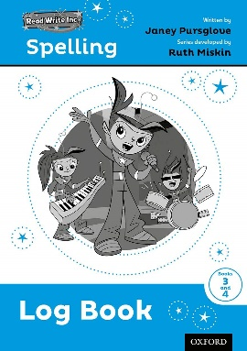  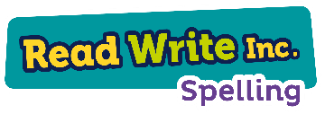  Learn weekly spellings:  Unit 1  like  dislike  agree  disagree  appear  disappear |   Your username and password are in your reading record.  Homework is set every week, but you can have a go on live mathletics games whenever you like.  Every week we check to see who has been earning the most points.  Have a look on the leader board when you are at school, it is on the stairs down to our classroom. | Geography  Create a poster about the United Kingdom. Try to include some facts.  E.g.  - Countries  - Rivers  - Bodies of water  - Mountains  - Cities  - Flags  - Population  - Popular foods  - Popular hobbies
Arithmetic Skills: & Place Value
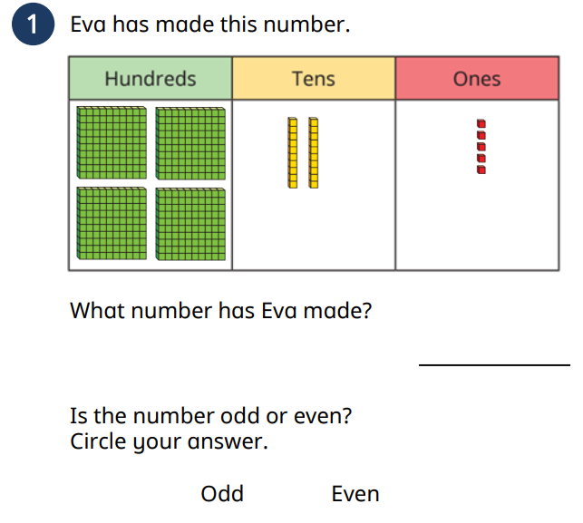
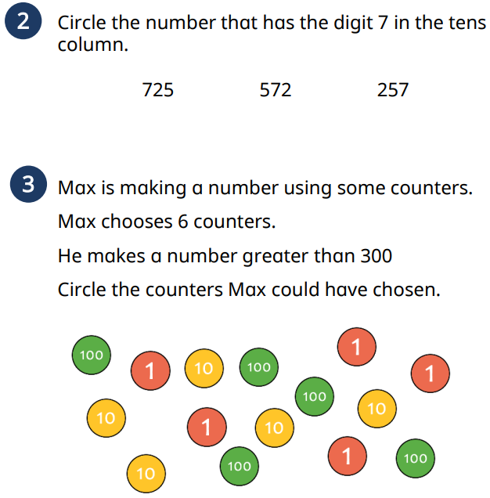

Year 3 – Autumn Term 1 Week 2 Homework

Home Reading | Spellings | Online Tasks | Topic Task
Please sign the reading record book each time you read your book.  It can be a mix of their reading book and books from home and school library.  TASK  What is your favourite book this at the moment?  Was it your home reader, Y3 class book, library book or a book from home?  What did you like about it? | Learn weekly spellings:  Unit 1  visible  invisible  complete  incomplete  dependent  independent | Your username and password are in your reading record.  Homework is set every week, but you can have a go on live mathletics games whenever you like.  Every week we check to see who has been earning the most points.  Have a look on the leader board when you are at school, it is on the stairs down to our classroom. | Religious Education  We know Christian houses might have bibles, children’s bible storybooks, palm cross, cross or crucifix, Christian music, bible verse fridge magnets, prayer cards, or church notice sheets.  Choose one and explain how Christians might use it.
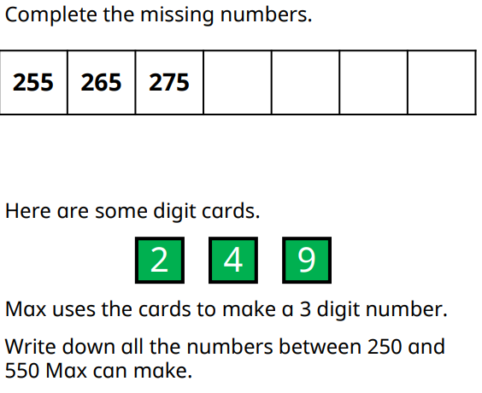
Arithmetic Skills: & Place Value
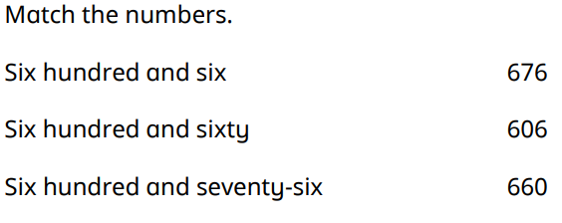

Year 3 – Autumn Term 1 Week 3 Homework

Home Reading | Spellings | Online Tasks | Topic Task
Please sign the reading record book each time you read your book.  It can be a mix of their reading book and books from home and school library.  TASK  Write a book review: Discuss the main characters, where they are and what they do in the story. | Learn weekly spellings:  Unit 1  happy  unhappy  kind  unkind  safe  unsafe | Your username and password are in your reading record.  Homework is set every week, but you can have a go on live mathletics games whenever you like.  Every week we check to see who has been earning the most points.  Have a look on the leader board when you are at school, it is on the stairs down to our classroom. | Science  Our topic this term is Lights And Shadows.  Create a labelled diagram which explains how shadows are created.  (I suggest you draw a torch, an object and a shadow – make sure you put them in the right positions!)
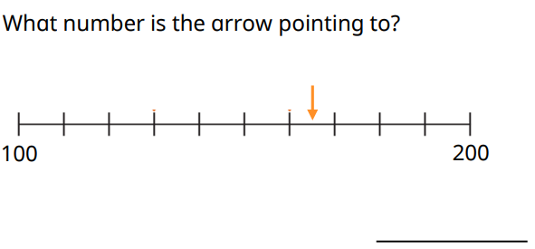
Arithmetic Skills: & Place Value
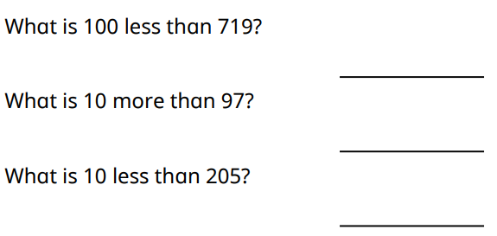

You can make notes on the number line. When you have decided what the number is, write a sentence explaining how you found it.

Year 3 – Autumn Term 1 Week 4 Homework

Home Reading | Spellings | Online Tasks | Topic Task
Please sign the reading record book each time you read your book.  It can be a mix of their reading book and books from home and school library.  TASK  Over the next few weeks we will be recommending books to each other. You can choose any book. Prepare to share one book you have enjoyed reading. | Learn weekly spellings:  Unit 2  possible  impossible  polite  impolite  patient  impatient | Your username and password are in your reading record.  Homework is set every week, but you can have a go on live mathletics games whenever you like.  Every week we check to see who has been earning the most points.  Have a look on the leader board when you are at school, it is on the stairs down to our classroom. | PE  This term we have been improving problem solving skills.  Draw a step-by-step explanation of one of our problem solving activities.  It must include:  - Words  - Pictures  (What did we do in PE this week?)
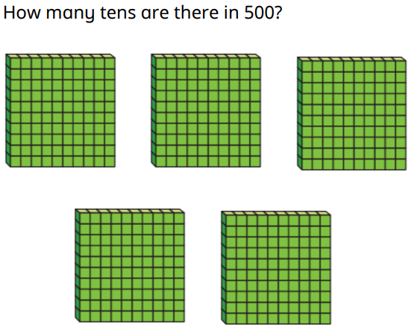
Arithmetic Skills: & Place Value

1. How many tens are in 100?
2. How many tens are in 200?
3. How many tens are in 300?
4. How many tens are in 400?
5. How many tens are in 500?

6. How many tens are in 1000?

Year 3 – Autumn Term 1 Week 5 Homework

Home Reading | Spellings | Online Tasks | Topic Task
Please sign the reading record book each time you read your book.  It can be a mix of their reading book and books from home and school library.  TASK  What book have you enjoyed reading the most so far in Year 3? | Learn weekly spellings:  Unit 2  like  dislike  kind  unkind  possible  impossible | Your username and password are in your reading record.  Homework is set every week, but you can have a go on live mathletics games whenever you like.  Every week we check to see who has been earning the most points.  Have a look on the leader board when you are at school, it is on the stairs down to our classroom. | History/Geography  We have been learning about Lancashire. Now it is your turn to investigate.  List between 5 and 10 facts about Lancashire.  Remember to search safely and ask a grown up to help if you need to.
Arithmetic Skills: & Place Value
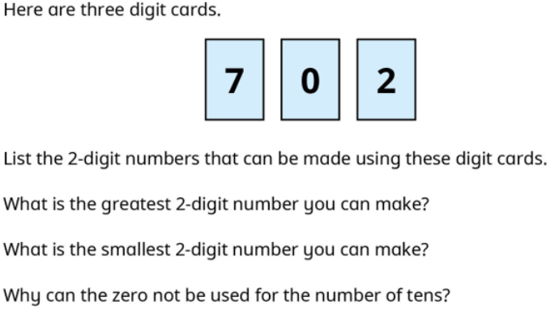

Year 3 – Autumn Term 1 Week 6 Homework

Home Reading | Spellings | Online Tasks | Topic Task
Please sign the reading record book each time you read your book.  It can be a mix of their reading book and books from home and school library.  TASK  Design a new book cover! Choose a favourite book from this half term. Consider what needs to go on the front cover to make people want to read the book. | Learn weekly spellings:  Unit 2  dis, un or im?  __possible  __like  __kind  __polite  __complete  __agree | Your username and password are in your reading record.  Homework is set every week, but you can have a go on live mathletics games whenever you like.  Every week we check to see who has been earning the most points.  Have a look on the leader board when you are at school, it is on the stairs down to our classroom. | PSHE  We’ve been learning how families are different.  Create a poster that we could share in class to help us to understand what is important in your family.  Ideas:  - The people  - Food  - Activities  - ???
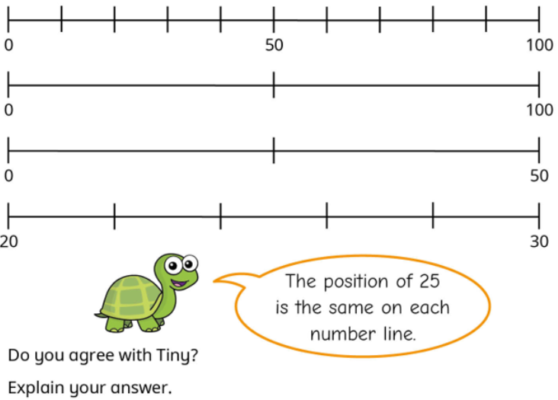
Arithmetic Skills: & Place Value

