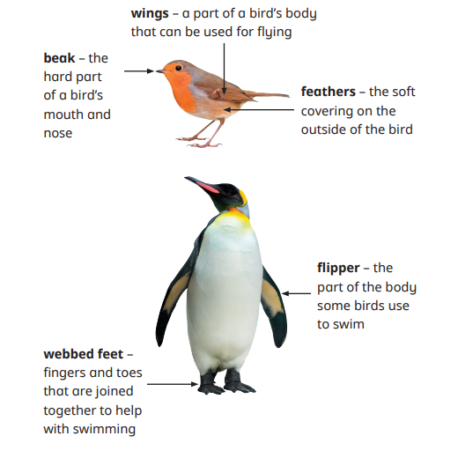
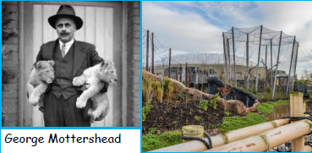
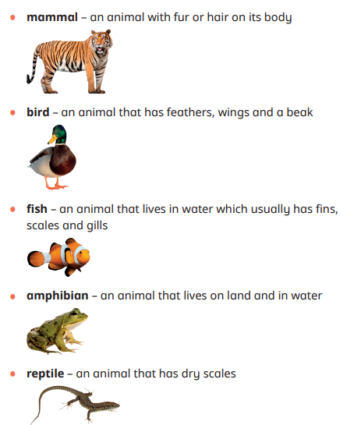

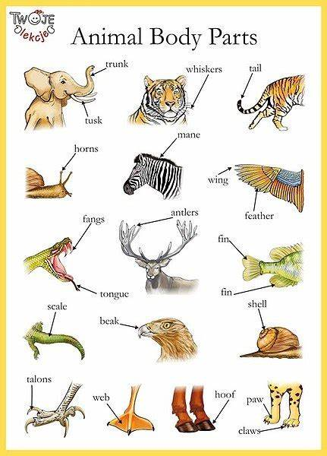
The founder of Chester Zoo.
He wanted animals to live freely in the zoo, not in cages.
Year 1- Autumn 1 and 2
Animals
Useful websites
Animals including humans - KS1 Science - BBC Bitesize

What are the features of birds? Birds have beaks, wings and feathers. • Some birds can fly. • Some birds cannot fly. • Some birds can swim. • Some birds cannot swim.
Can you name different parts of a fish? fin, tail, scales and gills. What is the function of each part? Some fish have scales on their bodies. • Fish have fins to help them swim. • Most fish have gills that help them breathe underwater.

Key Vocabulary
Vocabulary | Definition
amphibians | Amphibians live in the water as babies and on land as they grow older. They have smooth, slimy skin.
birds | All birds have a beak, two legs, feathers and wings.
fish | Fish live and breathe under water. They have scaly skin, fins to help them swim and they breathe through gills.
mammals | Mammals are animals that breathe air, grow hair or fur and feed on their mother’s milk as a baby.
reptiles | All reptiles breathe air. They have scales on their skin.
invertebrates | Animals that don’t have backbones
carnivores | Meat eating animals
herbivores | Plant eating animals
omnivores | Meat and plant eating animals

What do animals eat?
Meat, plants or both. Carnivores eat meat only. Herbivores eat plants and grains only. Omnivores eat meat and plants and grains.

How would you identify an amphibian?
Amphibians live on land and in water. • Amphibians have webbed feet. • Frogs, toads and newts are amphibians.
How do animals move?
Walk, swim, crawl, slither, swing, fly, jump.

What are the five animal groups?
Mammals, birds, fish, reptiles and amphibians.

Sticky Knowledge

