
Geography
What are the names of the countries of the UK?
England, Scotland, Wales and Northern Ireland.
Vocabulary | Definition
Map |  | Maps can be drawing or models. They help you find where you are and where you are going.
Continent |  | A continent is a large solid area of land. Earth has seven continents
Ocean |  | An. ocean is a huge body of salt water. Oceans cover nearly 71 percent of Earth's surface.
Weather patterns |  | Weather patterns are when the weather stays the same for periods of time.
Land |  | An area of the ground in which we live.
Sea |  | A sea is a body of saltwater much smaller than an ocean.
United Kingdom |  | It is made up of England, Scotland, Wales and Northern Ireland.

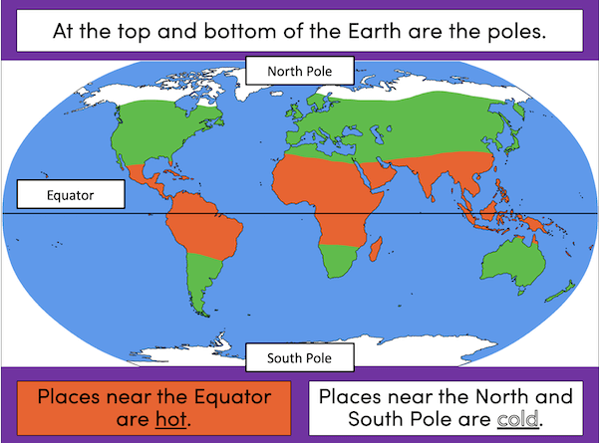
Autumn 1 Years 1 and 2

Continents and Oceans
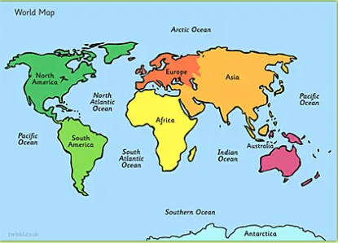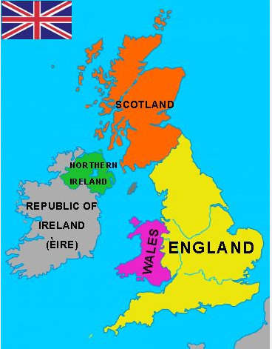
Where is the equator located?
Useful websites
https://www.youtube.com/watch?v=K6DSMZ8b3LE
https://www.youtube.com/watch?v=X6BE4VcYngQ
What are the names of the seven continents?
Asia, Africa, North America, South America, Antarctica, Europe, Australasia.

What are the names of the Five oceans?

Pacific, Atlantic, Indian, Southern, Artic.

What different types of weather is there?
Sun, rain, wind, snow, cloudy.

Sticky Knowledge
Key Vocabulary

