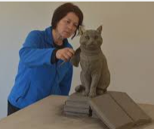
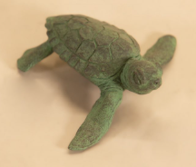
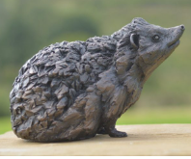
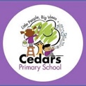

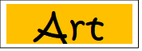
Sculptures
Year 1 and 2 Autumn 1

Art
Sticky Knowledge
Penguins, Pigs and Possums
How can you create texture?
Use different tools, leaves and twigs. Choose the correct brush size for painting the 3D model e.g, fine brush for a small section such as a beak.

Vocabulary | Definition
Sculptor | An artist who creates sculptures out of material such as wood, clay, metal, or stone.
Sculpture | A three-dimensional piece of art often carved, chiseled, or cast from stone, marble, wood or bronze.
Shade | A shade is where an artist adds black to a colour to darken it down.
Tones | Tones refers to how light or dark something is.
Shape | Shape is a flat area surrounded by edges or an outline. Artists use all kinds of shapes.
Line | Lines can be straight or curved; they can be horizontal, vertical or diagonal; and they can change direction.
Texture | Texture means how something feels. The appearance of texture is an important visual element.
Kneading | Kneading to work (dough, clay) into a mixture by pressing, folding, and stretching.
Rolling | Rolling to move by turning over and over.

Key Vocabulary
What technique do I need to use?
Make different shapes using clay: rolling, pressing, pulling, kneading.

.

What inspired Tanya do be a sculptor?
Tanya apprenticed for 7 years with her parents, who were both sculptors.

Who is Tanya Russell?
An artist who is best known for her animal sculpture, including a wide range of small animal sculptures and small animal statues.
.

Why does she sculpt animals?
She creates artwork thinking about her relationships with animals. How can her work improve the lives of animals.

Where can we see her sculptures?
Tanya exhibits in gardens and galleries across the country.

Useful Website…
https://www.tate.org.uk/kids/explore/top-5/top-5-sculptures#:~:text=What%20exactly%20are%20sculptures%3F,the%20artist%20wants%20to%20use

