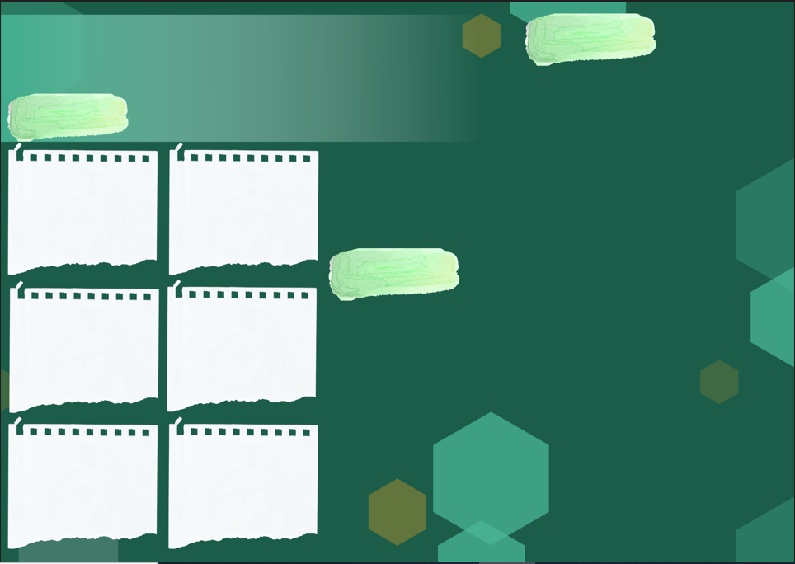
Geography
What are different types of settlement and land use?
There are generally three types of settlements: compact, semi-compact, and dispersed. Each is based on its population density. Compact settlements have the highest density of population.

How can you describe a European country (Greece) and a South American Country (Chilie)?
Greece has the longest coastline in Europe and is the southernmost country in Europe. The mainland has rugged mountains, forests, and lakes, but the country is well known for the thousands of islands dotting the blue Aegean Sea to the east, the Mediterranean Sea to the south, and the Ionian Sea to the west.
Chile is a long narrow country which extends like a ribbon down the west coast of South America. While the coastline is over 4,000 miles (6,437 kilometers) long, it is only about 61 miles (91 kilometers) wide.

How do you read thematic maps?
A thematic map focuses on the spatial variability of a specific distribution or theme (such as population density or average annual income), whereas a reference map focuses on the location and names of features.

Vocabulary | Definition
Latitude | Longitudes are vertical lines that measure east or west of the meridian in Greenwich, England
Longitude | Latitudes are horizontal lines that measure distance north or south of the equator.
Equator | An equator is an imaginary line around the middle of the planet. It is halfway between the north pole and the south pole, at 0 degrees latitude.
Tropic of Cancer | The most northerly circle of latitude on Earth at which the Sun can be directly overhead.
Tropics of Capricorn | The most southerly circle of latitude on Earth at which the Sun can be directly overhead.
Arctic Circle | One of the two polar circles and the most northerly of the five major circle latitude as shown on maps.
Antarctic Circle | One of the two polar circle and the most southerly of the five major circle latitude as shown on maps.
Prime/Greenwich Meridian and time zones | There are 24 time zones. There is an imaginary line running through the UK called the Prime Meridian. It runs through a place in London called Greenwich. The Prime Meridian splits the world into eastern and western hemispheres.

Useful websites
https://www.kids-world-travel-guide.com/facts-about-chile.html
https://kids.nationalgeographic.com/geography/countries/article/chile
https://kids.nationalgeographic.com/geography/countries/article/greece
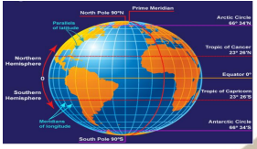
What are climate zones, biomes and vegetation belts?
A biome is a climate zone and the plants and animals that live in it. The Koppen classification system divides climates into five major types and many subtypes based on temperature and humidity characteristics. A microclimate has different climate conditions from the surrounding regions. A vegetation belt is an area with distinct plant types, determined by climate, soil, drainage and elevation.

The World’s Countries and key features – research
Autumn 1 Year 6

Sticky Knowledge
Key Vocabulary

