
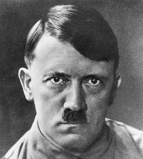
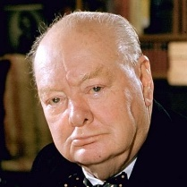

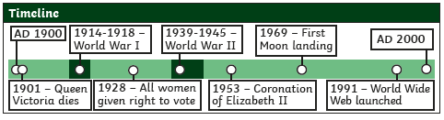
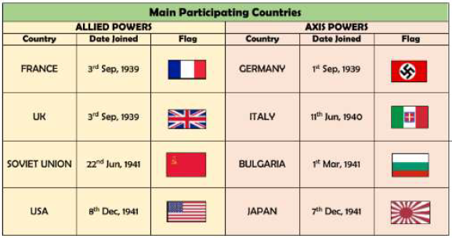
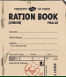
World War 2
Year 6 Autumn 1+2

Adolf Hitler
Winston Churchill
How were people’s diets different during World War II?

As a result of rationing, the use of fruit and vegetables became even more important during these years. People became reliant of vegetables and less meat.

What was rationing?
Rationing was introduced in Britain in January 1940. Certain foods such as butter, bacon and sugar were restricted. People could only buy limited amounts.
What was the Holocaust?

The Holocaust was a slaughter committed by Germany before and during WW2. It involved the murder of over 6 million Jewish people and millions of others. Many people perished in concentration camps.
What was the significance of Women’s jobs during the WW 2?
During WW2, women proved that they could do “men’s” work. With men away at war. They served as stenographers, clerks, radio operators, truck drivers and mechanics.

Useful Websites… Victorian Summer Holidays: Sun, Sea and Segregated Beaches | All About History (historyanswers.co.uk)

When did World War 2 begin?

On 1st September 1939, Germany invaded Poland. Britain and France (Poland’s allies) gave Germany notice to withdraw their troops. When they did not, Neville Chamberlain (The British Prime minister) declared war on 3rd September 1939.
What is an evacuee?

People expected cities to be bombed as the Germans tried to hit military or trade targets. This would put children in danger, so many were sent to live with families in the countryside until the war ended.
Ration Book
Vocabulary | Definition
Air-raid | An attack by enemy planes dropping bombs.
Anderson shelter | A small shelter made from corrugated steel to protect people in air-raids.
Allies | Countries (including Britain, France, the Soviet Union and the USA) who fought the Axis Powers.
Axis Powers | Germany, Japan, Italy and other countries that fought against the Allies.
Invasion | When an army or country uses force to enter and take control of another country or area.
Blackout | A wartime ban on streetlights and other lights at night, to reduce the risk of bombing by enemy planes.
Blitz | A prolonged period of German air raids on Britain. From the German ‘blitzkrieg’ which means ‘lightning war’.
Evacuation | Moving people from dangerous areas to safer places e.g. from big cities to the countryside to avoid bombing.
Rationing | Controlling the supply of food, clothes, petrol and other products to avoid or reduce shortages.
Occupied | Taken over by enemy forces.
Liberated | Freed from enemy control.

Sticky Knowledge
Key Vocabulary

