
Year 6 – Autumn Term 1 Week 1 Homework

Home Reading | Spellings | Online Tasks | Topic Task
Please sign the reading record book each time you read your book.  It can be a mix of their reading book and books from home and school library.  Create a vocabulary list from your reading books include::  - Definition  - Synonyms  - Antonyms  - Prefix/suffix | Suffixes  When we do not change the root word when a suffix beginning with a vowel is added  lighter  lightest  lightning  lightening  sprinted  sprinter  sprinting | Mathletics   | Science  Find out what these words mean and write a sentence using them.  Adaptation  Variation  Characteristics  Camouflage
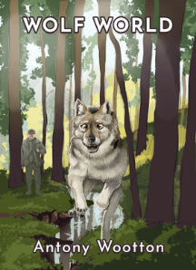
PurpleMash

Wolf World
by Antony Wootten Comprehension
Chapter 1

Arithmetic Skills:
Use the formal method taught to complete these calculations. Complete in your homework book.
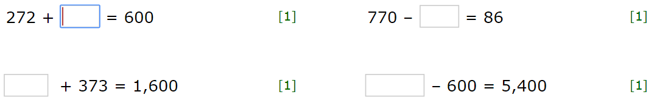

Year 6 – Autumn Term 1 Week 2 Homework

Home Reading | Spellings | Online Tasks | Topic Task
Please sign the reading record book each time you read your book.  It can be a mix of their reading book and books from home and school library.  Create a vocabulary list from your reading books include::  - Definition  - Synonyms  - Antonyms  - Prefix/suffix | Special focus  Words containing the letter-string ough  thoroughly  borough  although  doughnut  plough  drought  boughs | Mathletics | Art  Go for a nature walk with your parents, in your local area, you could visit a park near you like Corporation Park. Observe what kind of plants and creatures you see – draw them.
PurpleMash

Wolf World
by Antony Wootten Comprehension
Chapter 2
Arithmetic Skills
Use the formal method taught to complete these calculations. Complete in your homework book.
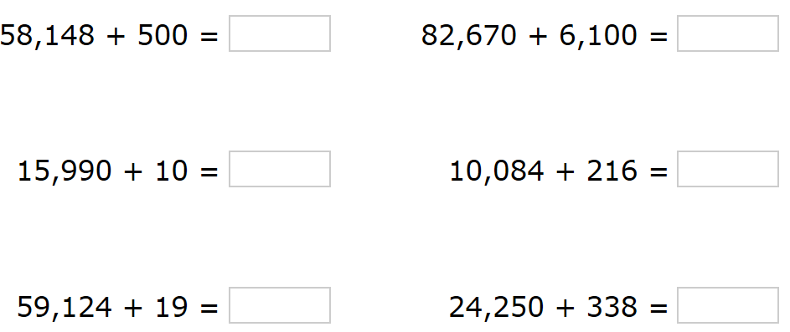

Year 6 – Autumn Term 1 Week 3 Homework

Home Reading | Spellings | Online Tasks | Topic Task
Please sign the reading record book each time you read your book.  It can be a mix of their reading book and books from home and school library.  Create a vocabulary list from your reading books include::  - Definition  - Synonyms  - Antonyms  - Prefix/suffix | Suffixes  Adding the endings –ing, -ed, -er, -est and –y to words ending in –e with a consonant before it.  appreciate  appreciating  appreciation  slimy  smiled  trader  nicest | Mathletics | Geography  Research physical and human features of Chile and Greece to create a fact file.
PurpleMash

Wolf World
by Antony Wootten Comprehension
Chapter 3
Arithmetic Skills
Use the formal method taught to complete these calculations. Complete in your homework book.
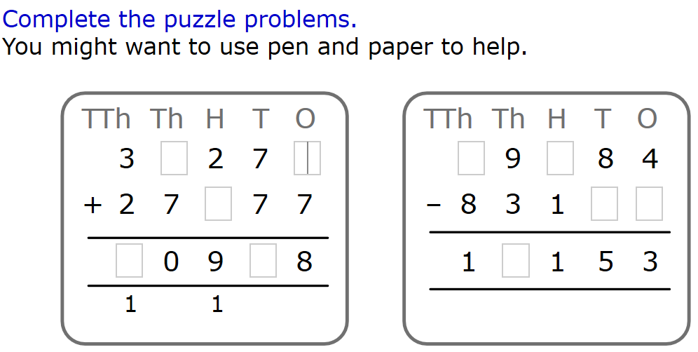

Year 6 – Autumn Term 1 Week 4 Homework

Home Reading | Spellings | Online Tasks |  | Topic Task
Please sign the reading record book each time you read your book.  It can be a mix of their reading book and books from home and school library.  Create a vocabulary list from your reading books include::  - Definition  - Synonyms  - Antonyms  - Prefix/suffix | Special Focus  Orange words:  communicate  community  committee  commitment  committed  harass  occur  occupy | Mathletics |  | RE  Write a list of things you would consider as charity.
PurpleMash

Wolf World
by Antony Wootten Comprehension
Chapter 4

Arithmetic Skills: & Place Value
Complete in your homework book. (no calculator allowed)
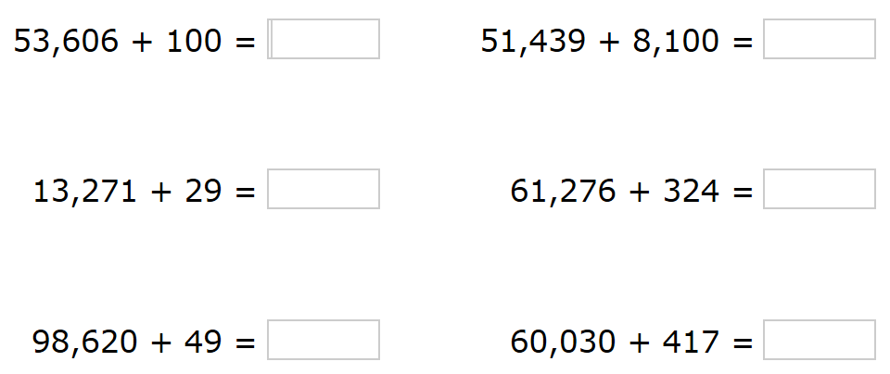

Year 6 – Autumn Term 1 Week 5 Homework

Home Reading | Spellings | Online Tasks |  | Topic Task
Please sign the reading record book each time you read your book.  It can be a mix of their reading book and books from home and school library.  Create a vocabulary list from your reading books include::  - Definition  - Synonyms  - Antonyms  - Prefix/suffix | Suffixes  To root words ending in –le or a consonant plus y.  The suffixes –ment, -ness, -ful, -less and –ly  gently  immediately  judgement  government  amazement  beautiful  laziness | Mathletics |  | Computing  Make your own computer program using 2code  Complete Free Code Gorilla 2Do:  https://www.purplemash.com/app/code/openended/freecodegorilla
PurpleMash

Wolf World
by Antony Wootten Comprehension
Chapter 5

Arithmetic Skills: & Place Value
Use the formal method taught to complete these calculations. Complete in your homework book.
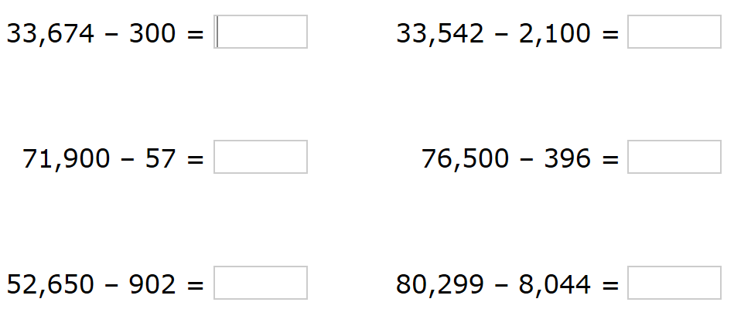

Year 6 – Autumn Term 1 Week 6 Homework

Home Reading | Spellings | Online Tasks |  | Topic Task
Please sign the reading record book each time you read your book.  It can be a mix of their reading book and books from home and school library.  Create a vocabulary list from your reading books include::  - Definition  - Synonyms  - Antonyms  - Prefix/suffix | Special Focus  Homophones:  principal  principle  bridal  bridle  proceed  precede  weary  wary | Mathletics |  | PSHE  Write a recipe for friendship.  Think about key ‘ingredients’ you look for in a friendship.
PurpleMash

Wolf World
by Antony Wootten Comprehension
Chapter 6

Arithmetic Skills: & Place Value
Use the formal method taught to complete these calculations. Complete in your homework book.
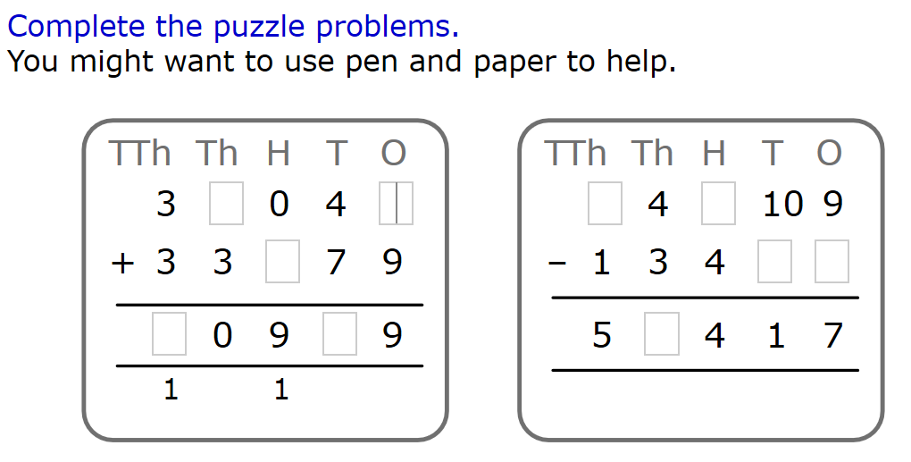

Year 6 – Autumn Term 1 Week 7 Homework

Home Reading | Spellings | Online Tasks |  | Topic Task
Please sign the reading record book each time you read your book.  It can be a mix of their reading book and books from home and school library.  Create a vocabulary list from your reading books include::  - Definition  - Synonyms  - Antonyms  - Prefix/suffix | Suffixes  Adding suffixes beginning with vowel letters to words of more than one syllable  Adding suffixes beginning with vowel letters to words ending –fer  prefer  preferred  refer  referring  regret  regrettable  regretted | Mathletics |  | French  Draw your own picture and label the colours and shapes in French (see French homework sheet).
PurpleMash

Wolf World
by Antony Wootten Comprehension
Chapter 7
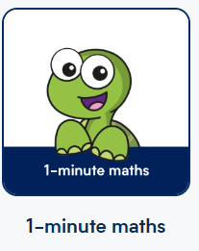
Arithmetic Skills: & Place Value
Complete using the link below. Ask for the three-word code.

whiterosemaths.com/digital-tools



