
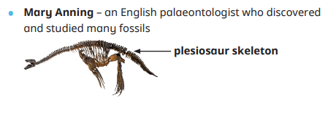
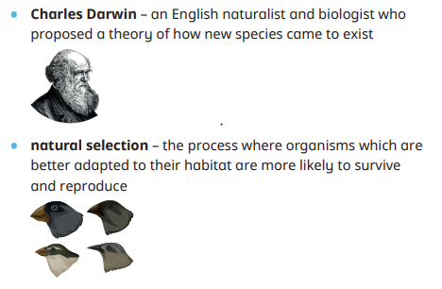
Year 6 Autumn

Science
Useful websites
What is evolution?
https://www.bbc.co.uk/bitesize/topics/zvhhvcw/articles/zxwcbqt
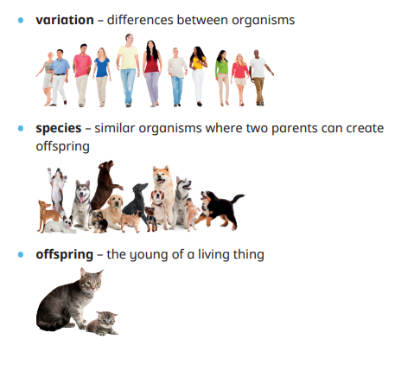
Adaptations Fossils and variation
…
Sticky Knowledge

What is inheritance?
Parents pass on characteristics to their offspring such as hair and eye colour. This process is called inheritance.
Why does evolution occur? Evolution allows animals and plants to better adapt to their environments or habitats so that they can survive. • Evolution explains how animals and plants have developed over time from simpler life forms that lived millions of years ago.

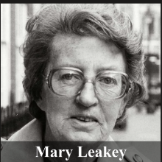
British paleoanthropologist who made several fossil finds of great importance in the understanding of human evolution.
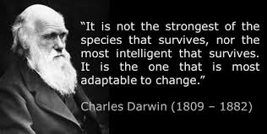

How are fossils formed? Fossils are formed when an animal or plant dies. When an animal dies the soft parts decompose and leave the skeleton. • The skeleton is buried by sediment which compacts over time. • Water seeps down into the rock and replaces the skeleton with minerals found in the water. • This produces an imprint in a rock of a living thing.

Key Vocabulary
What was Darwin’s theory of evolution? Charles Darwin suggested the ‘Theory of Evolution’. Darwin also suggested that organisms change their characteristics over a long period of time, so that they can successfully adapt to their environment or habitat.
.

Vocabulary | Definition
evolution | A change in characteristics in animals and plants over a long period of time. | Anther, stamen, pollen, ovary, stigma  When a living organism creates a new organism in its likeness.
inheritance | the passing on of characteristics from parent to offspring | The reason for something doing something e.g. the function of a root absorbs water and nutrients tp feed the plant and it anchors the plant to the ground.
adaptation | Characteristics which improve an animal’s chances of survival in a habitat. | Seed dispersal allows plants to spread out from a wide area and avoid competing with one another for the same resources.
Fossil | The imprint in a rock of a living thing that lived a long time ago | The weather conditions in a certain area or across the globe. Climate change can be affected by humans.
characteristics | The features of an organism, used to identify individuals or a group | The surroundings or conditions a living thing operates in.
Organism | A living thing | The process of turning sunlight into energy by the leaves.
Galapagos Islands | a collection of islands found near South  America that Charles Darwin visited in 1835 | The point at which a seed has swollen and split and sends out a root.
decompose | a process of a material breaking down.

How have animals adapted over time? Animals in cold environments have characteristics which allow them to survive. For example, they may have thick fur or blubber. • Animals in desert environments have characteristics which allow them to survive in extreme heat. Some of these include thin fur and long eyelashes.
Discuss the work of Mary
Anning:
Mary Anning was a famous palaeontologist who discovered many fossils during the 1800s. She made many discoveries such as finding plesiosaur, ichthyosaur and pterosaur fossils.

