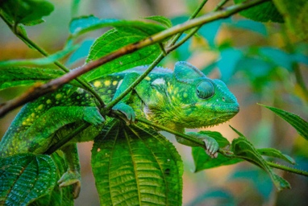
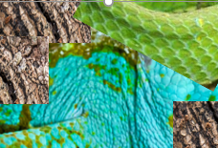
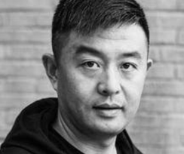
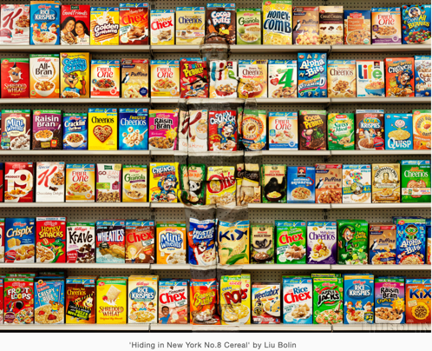


Useful websites… https://allthatsinteresting.com/animal-camouflage-pictures#54

Survival
Year 6 Autumn 1

Vocabulary | Definition
Camouflage | The art of blending in with your surroundings in order to avoid detection.
Composition | Term given to a complete work of art, specifically, how all its elements combine to produce an overall effect.
Cross hatching | A technique used to create tone. The lines cross over the top of each other.
Resizing | Making it bigger or smaller. Pixel-based images can be made smaller, however when you increase the size, it loses quality.
Rotating | A type of transformation that takes each point in a figure and rotates it a certain number of degrees around a given point.
Repeating | A repeat pattern is the repetition of lines, shapes, tones, colors, textures and forms.
Digital media | Any form of media accessed by a machine. This includes TV, computers and smartphones.
Wet and dry media | Water colours, coloured pencils and pastels.

Key Vocabulary
How will we enhance the image? Experimenting with colour changes and effects and by resizing, rotating, repeating.

Why Biolin chose this style? On November 16, 2006 when Suo Jia Cun was forcibly demolished, he decided to use his works to make a stand against the atrocity. To show the state of artists in society, that their living and working places had not been protected.

Who is Liu Bolin? Biolin is a Chinese performance artist and photographer known for using chameleon-like methods to immerse himself in environments, earning him the nickname “The Invisible Man.”

What techniques will we use? Explore cross hatching techniques using wet and dry media and evaluate the effectiveness – which type of media was better/ easier to use to achieve camouflage?

How he accomplished his mission? The stillness of his body during the production of the work is a silent protest. Resistance to movement and nature are both reflected in his work. He is fighting for freedom and for the social status of the artist with his body.

What inspired Bolin? In 2005, in Beijing he was working as an artist’s assistant. Beijing’s art world was thriving. All 140 artists in Suo Jia Cun were exclusively making art, and this is what he knew he wanted to do.

Sticky Knowledge

