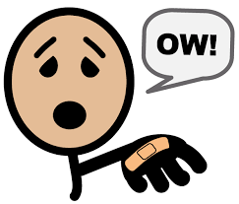
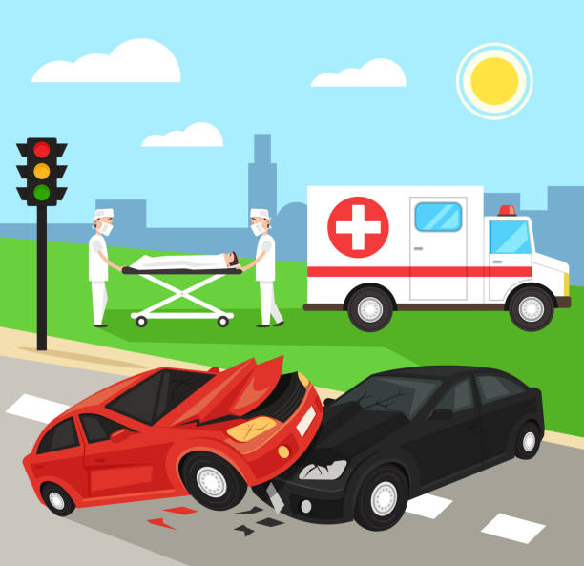
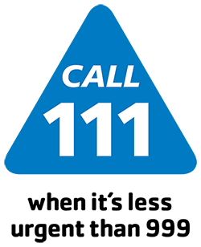

Year 5: Summer 2
PSHE
Health and Wellbeing: How can we help in an accident or emergency?
Key Vocabulary
Sticky Knowledge




What should you do if your first aid is not working OR if you don’t know what to do?
A: Get help - shout or call for help to come, get an adult or call 999.
Vocabulary | Definition
basic first aid | the first and immediate assistance given to any person with either a minor or serious illness or injury, with care provided to preserve life
burns/scalds | an injury to the skin or other organic tissue primarily caused by heat or due to radiation, radioactivity, electricity, friction or contact with chemicals
cuts/bleeds | make an opening, incision, or wound in (something) with a sharp-edged tool or object causing loss of blood
choking | have severe difficulty in breathing because of a constricted or obstructed throat or a lack of air
asthma attacks | a condition in which your airways narrow and swell and may produce extra mucus
allergic reactions | sensitivities to substances called allergens that come into contact with the skin, nose, eyes, respiratory tract, and gastrointestinal tract. They can be breathed into the lungs, swallowed, or injected

If someone has a head injury what should you do?
A: NOT move them, keep comfortable, call / shout for help.

Basic First Aid:
*Burn, scald, cuts, bleeding.
*Choking, asthma, Allergic reactions.

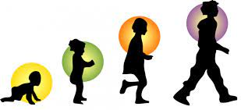
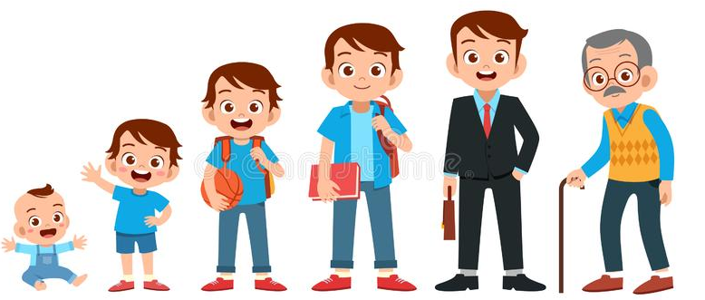
Year 5: Summer 2
Key Vocabulary
Sticky Knowledge
Health and Wellbeing: How will we grow and change?
Vocabulary | Definition
puberty | the period during which adolescents reach sexual maturity and become capable of reproduction.
adolescent | The social and emotional stage of development between childhood and adulthood.
emotions and feelings | emotions start as sensations in the body, feelings are generated from our thoughts about those emotions
advice and support | guidance or recommendations offered with regard to future action

Name ways in which your body will change during puberty?
A: Hygiene, hair, sweat, male/female adolescent changes
More detail to follow from school.
How might puberty make you feel?
A: Worried, scared, confused, angry, happy, excited… any emotion is fine and valid.
Why is it important to keep yourself clean during puberty?
A: Oily skin, hair, sweat - it’s important to wash your clothes and body regularly and use soap to wash and deodorant.
What should you do if you are worried, confused or need help?
A: Talk to a trusted adult at school, home or mosque.

