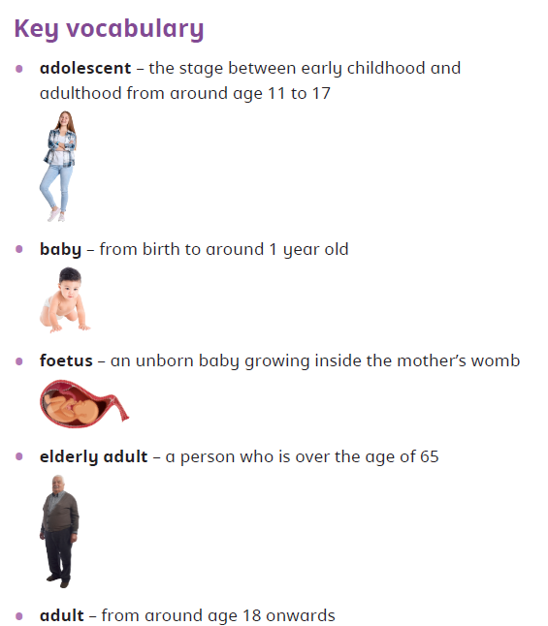
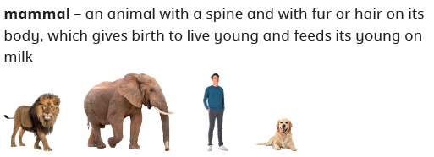

Useful websites

Science
Year 5 Summer 2 Faster, Higher, Stronger

Animals Including Humans
…
Sticky Knowledge

. What are the milestones in the growth of a child or toddler?
Most babies and toddlers hit certain milestones in their first two years of life, such as crawling and walking. Throughout childhood, children grow and develop at a rapid rate in terms of their mass, height and brain development.

What are the six stages of the human life cycle?
The human life cycle has six main stages – foetus, baby, child, adolescent, adult and elderly adult.

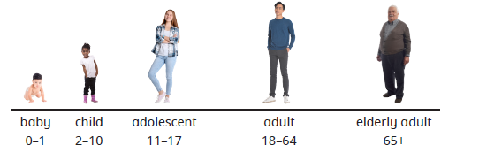

Key Vocabulary

.

What happens as adults age? The human body gradually changes with age. For example, skin loses elasticity, resulting in wrinkles, bones may become weaker and height may decrease.

Vocabulary | Definition
Hormone | a chemical released by the body that causes physical and emotional changes during puberty
adolescent | the stage between childhood and adulthood, from around age 11 to 17
reproduce | to produce offspring
milestone | a significant event in a person’s life
puberty | the process that prepares humans for reproduction
life expectancy | the average time a person may expect to live
foetus | an unborn baby growing inside the mother’s womb
gestation | the period of time that a foetus develops in its mother’s womb

Is there a relationship between the gestation period of an animal and its lifespan?
Usually, the longer the gestation period of an animal, the longer the lifespan. Humans have a relatively short gestation period compared.
What does lifespan mean?
The lifespan of an animal is how long the animal is alive.

