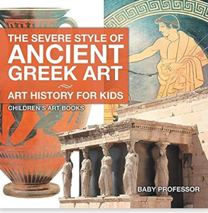
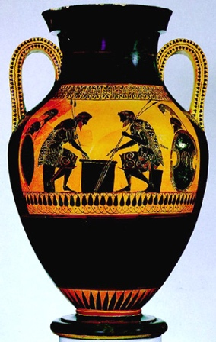
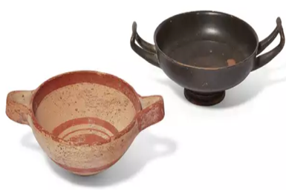
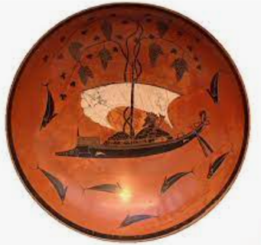


Art
Useful Books… The Severe Style of Ancient Greek Art by Baby Professor
Vocabulary | Definition
Black figure art | The pottery had glossy black figures painted using slip, that turned black during the process of firing.
Pinch pot technique | A simple form of hand-made pottery produced from ancient times to the present.
Kylix | A wide-bowled drinking cup with horizontal handles
Slip | Clay mixed with water to thin the clay down into a liquid state. Slip is used to join pieces of clay together. E.g. to attach handles to mugs.
Forms of Greek Art | Greek art is mainly five forms: architecture, sculpture, painting, pottery and jewelry making.

Key Vocabulary
How will we enhance the drawings? Use your knowledge of myths and legends to create figures and tell a story. Sketch traditional Greek patterns with a pencil or pointed tool.

What techniques will we use? A pinch pot technique. First roll the clay into a ball. Next push your thumb into the centre. Then pinch continuously, until your chosen shape and thickness of your kylix.
What do the pictures represent?
Greek art shows narrative scenes from popular myths and legends particularly those about Heracles and daily life.
Is Greek pottery valuable?
The market for Greek vases has always been strong, collectors buy ancient pieces to sit alongside modern art. Small pieces start from around £1,000 while larger and rarer pieces can sell for hundreds of thousands.

What did the Greeks use the pottery for?
The Greeks used pottery vessels primarily to store, transport, and drink such liquids as wine and water. Smaller pots were used as containers for perfumes and medicines.
Who was Exekias?
Exekias, was a Greek potter and painter who, with the Amasis Painter, is considered the finest and most original of black-figure masters of the mid-6th century BC and is one of the major figures in the history of the art.

Faster, Higher Stronger
Year 5 Summer 2

Sticky Knowledge

