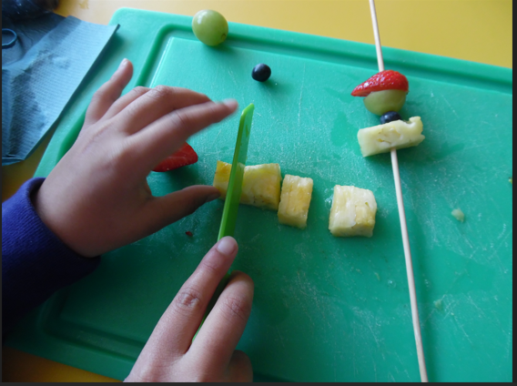
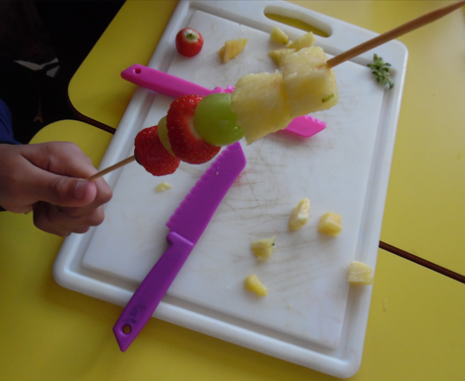

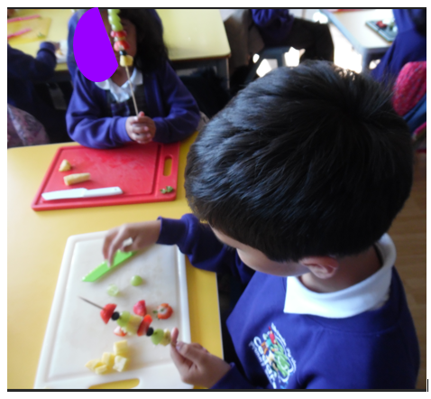

The first Cookery Club was very successful. We learned how a pineapple can be cut up, chopped up our own fruit and made fruit kebabs – one to eat and one to save for later! We also tidied and washed up and cleaned the tables.

