Year 6
Unit of Work | NC Expectations | Unit End Points
Summer 2  DT- combining learning from across design and technology skills bases-structures, mechanical systems, electrical systems, ICT programming and control  - Task: A panoramic display for Blackpool Illuminations (in miniature) with moving parts and lights or  - A fairground ride with movement and lights.  - Choose one  Key Vocabulary:  Mechanical systems  electrical systems  ICT-CAD  control  join/cut/shape  strengths  weaknesses  illumination/fairground ride  Tools:  light switches  buzzers  motors  process  bradawl  dowel  stiffen  reinforce  structures  Research, design, make evaluate | 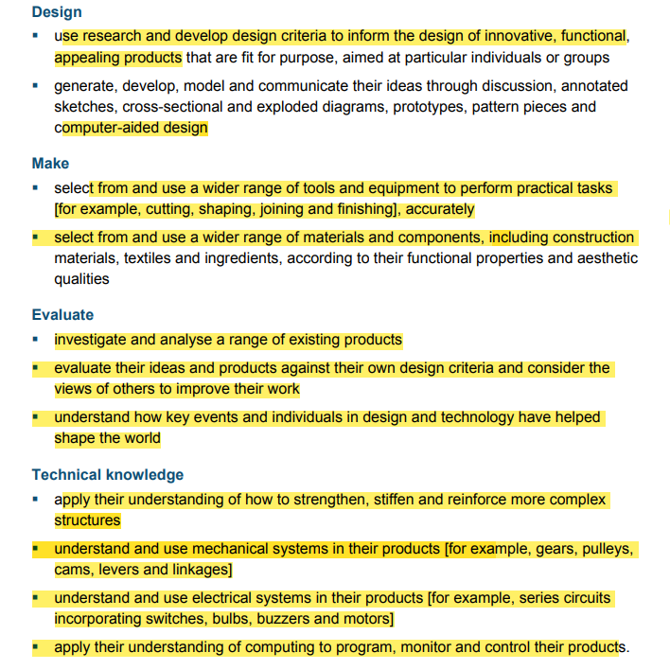 | - Can I evaluate and investigate existing products? Fairground rides or illuminations  - Can I design illuminations or fairground ride with a set design criteria (consider the purpose and user)  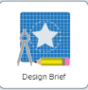  - Can I plan the design process using CAD? (computer Aided Design) * Use design brief on Purple Mash to plan the sequence of their design.  - Can I identify strengths and weaknesses of my design?  Can I make a prototype?  - Can I make my design (illumination/ fairground ride)?  *may take more than one session  Please note during the making children should:  - use the correct terminology for tools, materials and processes.    - will use bradawl to mark hole positions.  - will use hand drill to drill tight and loose fit holes.  - join materials using appropriate methods.  - will build frameworks to support mechanisms.  - will stiffen and reinforce their structures.  - will incorporate electrical systems or mechanisms into their design.  - Can I evaluate my design and test if they are fit for purpose?
Spring 1  Hero’s and Villains  DT- Food Chefs, food heroes, designing a healthy menu/eatwell plate  Task: Use inspiration from Jamie Oliver and create a menu with a starter, main and dessert.  Link to school meals and healthy menus  Key Vocabulary:  Food hero  menu- starter, main, dessert  food groups  ingredients  sequence  chop/grate/peel/combine/mix  healthy  balanced  Research, design, make evaluate | 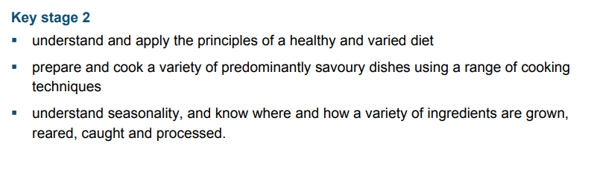  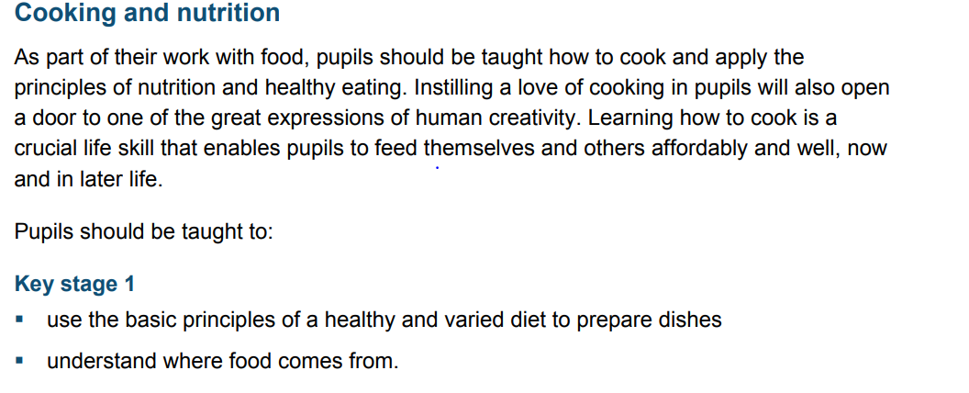 | - Can I research and investigate food heroes e.g. Jamie Oliver.  - Can I research and investigate healthy menus? ( linked to the eat well plate)  - Can I design my own healthy menu with a set design criteria?- considering all food groups.  Note: A menu with a starter, main and dessert  4.Can I plan and sequence my work in order? – organise their menus  5 Can I use a wide range of skills to make my menu?  May take more than one session or a full afternoon  6. Can I evaluate my own work and that of others against a set design criteria.

