Year 5
Unit of Work | NC Expectations | Unit End Points
Amazon Adventure- Summer 1  3D Textiles- using gussets, using patterns, joining with seam allowance and combining fabrics  Bag with pockets  Key Vocabulary:  gusset  apron  pattern pieces  back stitch  running stitch  over stitch  blanket stitch  fabric  pin and tack  Research, design, make evaluate | 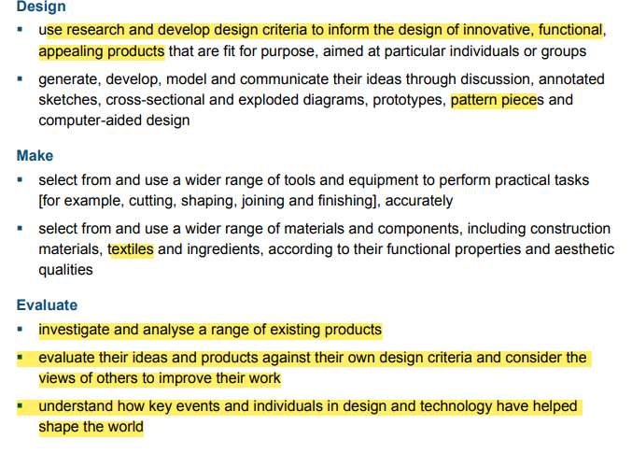 | - Can I research and investigate a range of bags/ items made using textiles? (uses, different fabrics/ designs) –link to web based research.  2. Can I understand how key people have influenced designs?  (Look at key designers 7 Textile Designers Who Changed the World (findcourses.co.uk)- teacher article)  Designers e.g. Cath Kidston/William Morris/Laura Ashley  3.Can I design my own product? Bag with pockets  Can I identify strengths and weaknesses of their design?  4.Can I draw pattern pieces to make my design?  Can I pin and tack fabric together?  5. Can I use a variety of stitching methods e.g. back stitch, running stitch, over stitch, blanket stitch ?  6. Can I evaluate my work and consider if it is fit for purpose?  (test if it is good for carrying items for an explorer)
Spring 2- inventors and Inventions  Mechanical systems- Cams, pulleys and gears  Make an orrery  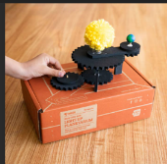  (shows model of the  Planets and moves)  Key Vocabulary:  orrery  gears  mechanism  electrical systems  motors  cams  pulleys  diagrams/sketches  prototype  Research, design, make evaluate, improve | 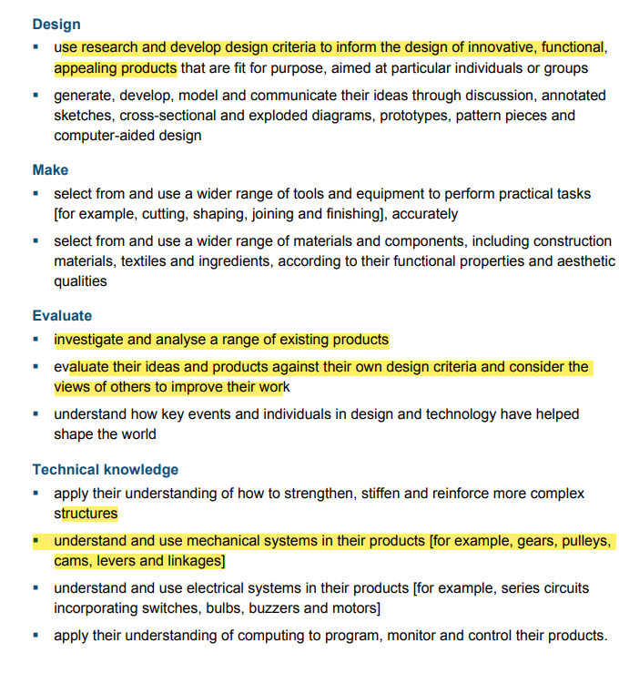 | 1.Can I investigate and research how gears and mechanisms work?  See twinkl ppt. marvellous mechanisms.  Can I use the technical vocabulary cams, pulleys, gear?  2. Can I research what an orrery is?  2. Can I create a specific design with a list of tools needed?  3. can record my ideas in a variety of ways? - annotated diagrams, sketches, step by step drawings.  4. Can I make a prototype and choose a final design?  5. Can I complete my final design?  Children can use electrical systems e,g, motors in my design.  6. Can I evaluate my work and suggest improvements?  Spinning Space Orrery | DIY for Beginners | KiwiCo  useful website step by step process
Food- Food from another culture  Autumn 2-  Chinese  Key Vocabulary:  ingredients  culture  Specific vocab to the food chosen by class teacher  measure/chop/peel/grate/combine  dish  taste  test  Research, design, make evaluate | 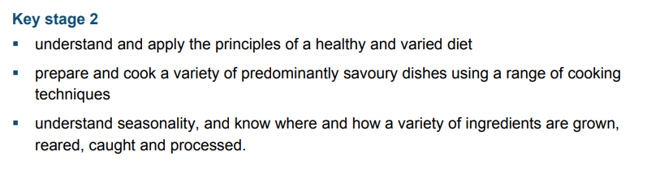  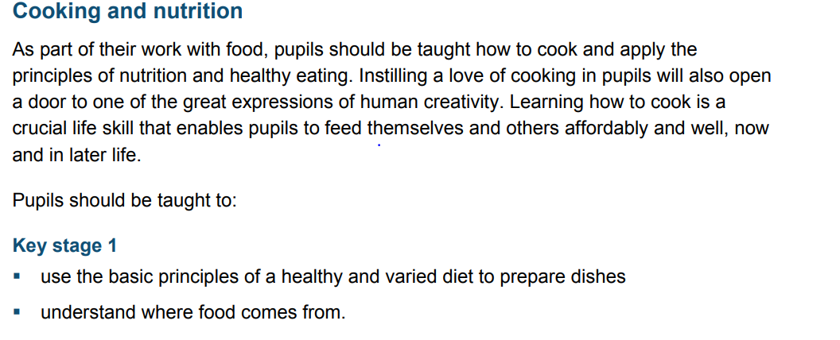 | 1. Can I research and evaluate food from another culture? e.g. Chinese  web based and book research  *Twinkl ppt. global food as a starting point.  2.Can I explore ingredients from another culture?- tasting  3. Can I design my own dish using ingredients from another culture?  4.Can I plan the step by step process of my design?  5.Can I make my final dish?  Can I measure, chop, grate, peel and combine ingredients to make my final dish?  *children to taste own and other childrens dishes  6. Can I evaluate my own dish and that of others?  *food review

