Year 4
Unit of Work | NC Expectations | Unit End Points
Autumn 1-Sparks May Fly  ICT and electrical systems- control and electrical components  Torch/ Reading Light  Key Vocabulary:  torch  electrical circuit  batteries  prototype  strength  sequence  weaknesses  Torches KS2 | Year 4 DT lessons | PlanBee-(use for ideas/inspiration)  Research, design, make evaluate | 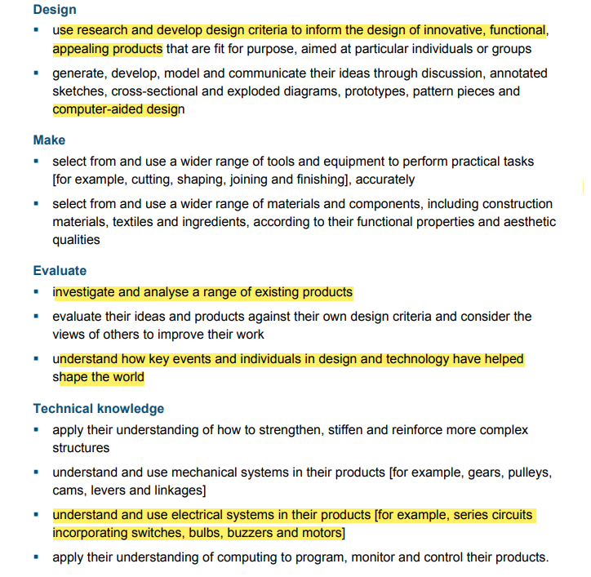 | 1.Can I research and investigate how torches/reading light work?  *(link to the invention of the light bulb- Thomas Edison and discovery of Electricity-Benjamin Franklin)-This may be covered in other subject areas but needs linking.  *Note: Exploring electrical circuits-will take place in Science but if needed plan a knowledge session here to explore circuits.  3.Can I design my own torch/ reading light with a design criteria?  4.Can I plan a sequence of actions (inc. use of CAD) to make their torch/ reading light?  *CAD- Computer Aided Design  Use 2chart on Purple Mash  5. Can I create a prototype and discuss strengths and weaknesses of my prototype?  6.Can I create my final product? (torch/reading light)  Can I evaluate my own work and work of others against a design criteria?
Spring 2 Passport To Europe  Textiles Seams, stiffening and strengthening, materials and fastenings  Make a purse to carry money/passport  Key vocabulary:  Money containers  Purse/wallet/ money bag  simple stitch  running stitch  pattern piece  sew  product  purpose  Research, design, make evaluate | 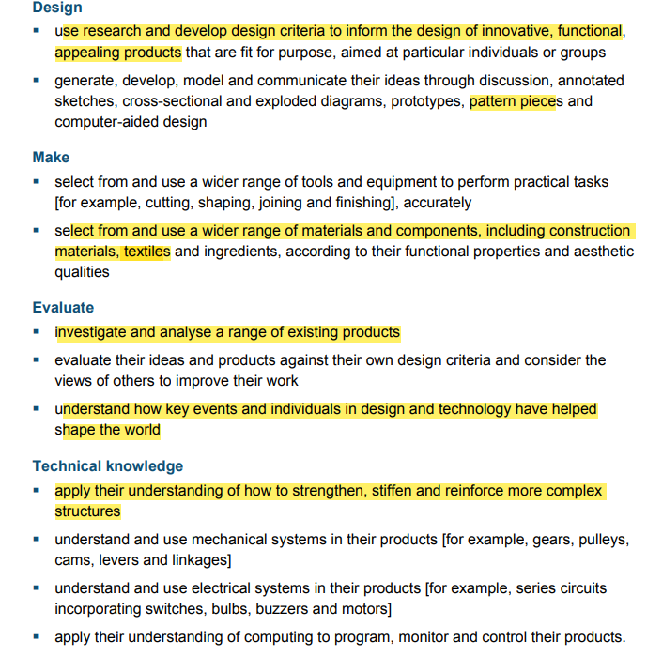 | 1.Can I research and investigate money containers? (fabric purses/ passport holders  Can I consider the needs of the user?  2 and 3- Can I join fabric with a simple stitch?  Can I join fabrics with a running stitch?  Can I over sew?  4. Can I design my own money container?  Can I identify strengths and weaknesses of my design?  5. Can I make my own money containers?  6. Can I evaluate my own product and consider its fit for purpose?
Summer 2- Hunted  Food- Savoury Food  Pizza- make dough and add healthy toppings  Key Vocabulary:  savoury  sourced locally  world  ingredients  healthy  taste  texture  vegetables  chop/measure/mash/blend  Research, design, make evaluate | 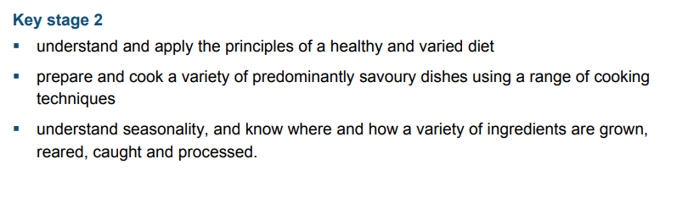  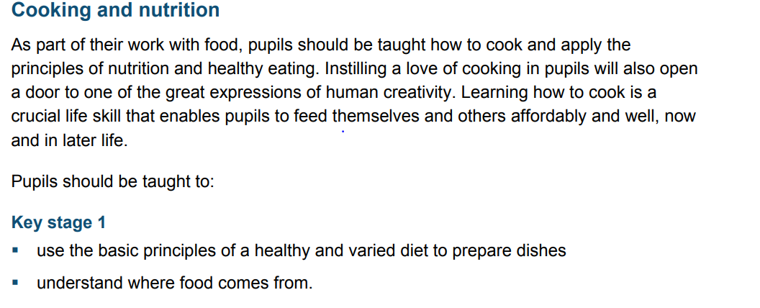 | 1. Can I develop understanding of food sourced locally and from around the world-  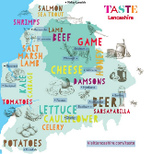  * focus on locally food sourced from Lancashire e.g cheese  2.Can I research and investigate savoury food?  e.g. pizza/pastries/bread  3.Can I measure, chop, mash and blend ingredients?  4. Can I design a savoury dish (pizza) and discuss where ingredients come from?  *link to making healthy food choices  5. Can I make a savoury dish and consider healthy food choices? Can I taste my work?  6. Can I evaluate my work against my design criteria?

