Year 3
Unit of Work | NC Expectations | Unit End Points
Healthy Humans- Autumn 2  Food- Eat well Plate- Simple Dish  Food for a picnic Include individual food items (e.g. hard boiled eggs, frittata,  pasta salad, potato salad, savoury / cheese scones).  Research, design, make evaluate  Key Vocabulary  farmed  chop/measure/weigh  combine  balanced  main course  *Already covered salads in Year 2. | 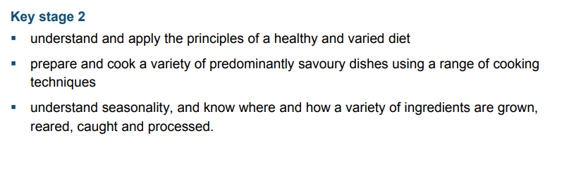  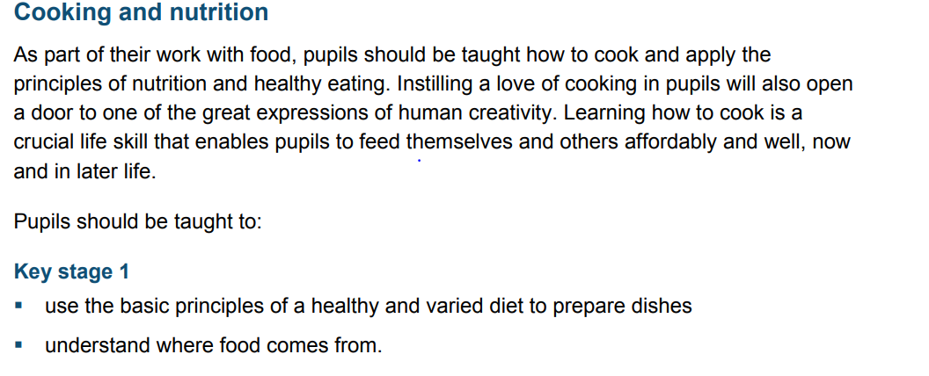 | 1. and 2. Can I research where food comes from? (grown/farmed- countries and continents)  3. Can I cut, chop, measure and weigh ingredients?  4. Can I use my existing knowledge (eat well plate) to design food suitable for a picnic?  5. (make) Can I use a wide variety of ingredients and techniques (cutting, chopping, measuring, weighing) to prepare and combine ingredients safely?  6.Can I test and evaluate their food for a picnic?  *optional- Can I grow something to add to my picnic lunch.
Spring 2- The Iron Man  Mechanical systems- Linkages and Leverages  Pop up Storybook/ story board connected to the Iron Man.  Research, design, make evaluate  Key Vocabulary:  linkages  levers  waving hand  moving flag  snapping crocodile  clapping hands  join  Research, design, make evaluate | 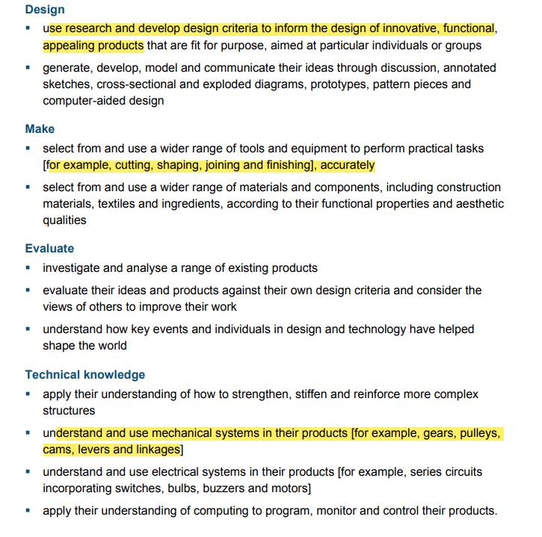 | 1.Can I investigate and analyse existing pop up storybooks?  2. and 3 Can I can explore a range of levers and linkages e.g waving hand, moving flags, snapping crocodiles, clapping hands?  4. Can I design my storybook/ storyboard that will use levers and linkages? (Children can plan what tools and materials they will use (scissors, card, paper fasteners, decorative materials)  5. Can I make a product using levers and linkages?  (Children can safely measure, mark out, cut assemble and join with some accuracy.)  6. Can I evaluate my own work and adapt it?
Summer 2- How does your garden grow?  Structures- shell and frame structures and strengthening  Garderners box to hold tools  Research, design, make evaluate  Key Vocabulary:  CAD- computer Aided Design  3D nets  strengthen  stiffen  fold/shape/corrugating/ribbing  laminating  stages  shell  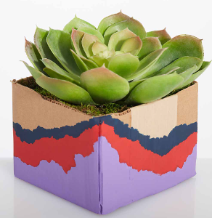  frame | 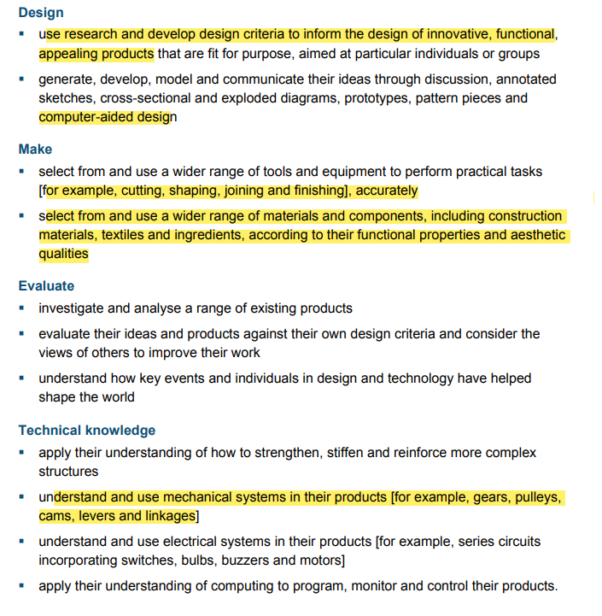 | 1. Can I investigate a range of shell and frame structures? (planter box/frame ).  2. Can I explore a range of 3D nets?  Can I strengthen and stiffen structures using a variety of techniques?  e.g. folding and shaping, corrugating, ribbing, laminating.  3a. Can use my knowledge of existing products to design my own gardeners box?  3b.Can I create designs on paper(annotated sketches) and through use of ICT (CAD)?- use purple mash tool – 2 design and make  4.Can I create my own structure (gardners box) using 3D nets?  Apply skill  Can I strengthen and stiffen structures using a variety of techniques?  e.g. folding and shaping, corrugating, ribbing, laminating.  5.Can evaluate and adapt my work?

