Year 2
Unit of Work | NC Expectations | Unit End Points
Spring 1Explorers Mechanisms- Wheels and Axles  Key Vocabulary:  Research, design, make evaluate  wheel  axle  attach  chassis  fixed axle  unfixed axle (free moving) | 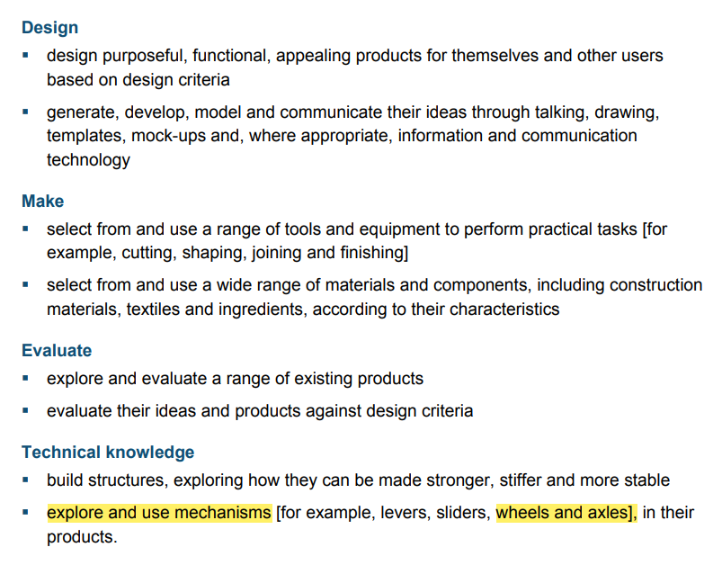 | 1.Can I research existing vehicles and ask questions? (vehicles)  2.Can I attach paper, card and wood?  Can I explore how a fixed axle and moving axle work?  3. Can I design a vehicle with a design criteria?  4.Can I make my vehicle?  Can I attach wheels to a chassis using an axle?  5. Can I test and evaluate my design?
Spring 2- The Farm Shop  Food the eatwell plate- where food comes from, principles of a healthy diet  Key Vocabulary:  salad  ingredients- rocket, lettuce, tomatoes  carrot etc (chosen by the teacher)  seasonal  safely  healthy  hygienically  combine/mix  grate/cut/chop/tear  Research, design, make evaluate | 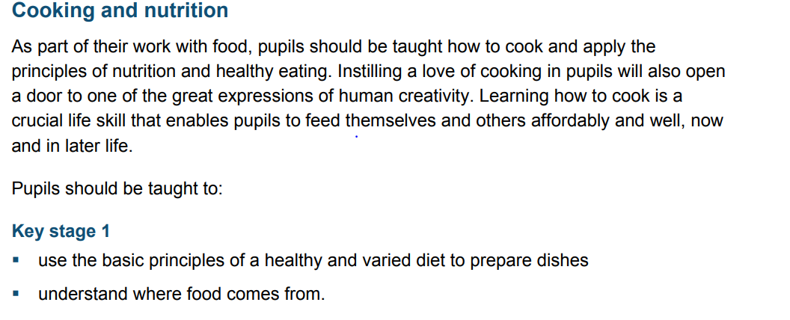 | 1. Can explore existing salads and investigate how they taste?  2. Can I cut, peel, grate, chop a range of ingredients?  3. Can I design a seasonal salad using my knowledge of a healthy diet?  4.Can I work safely and hygienically to make a seasonal salad?  Can I name the ingredients I am using and combine them?  5. Can I evaluate my seasonal salad and suggest  Improvements?
Summer 1- Wind in the Willows  Textiles- using a template, simple joining, choice of stitches, choice of materials  (puppets)  Key Vocabulary:  running stitch  sew  needle  eye of the needle  thread  over stitch  decorate  Research, design, make evaluate | 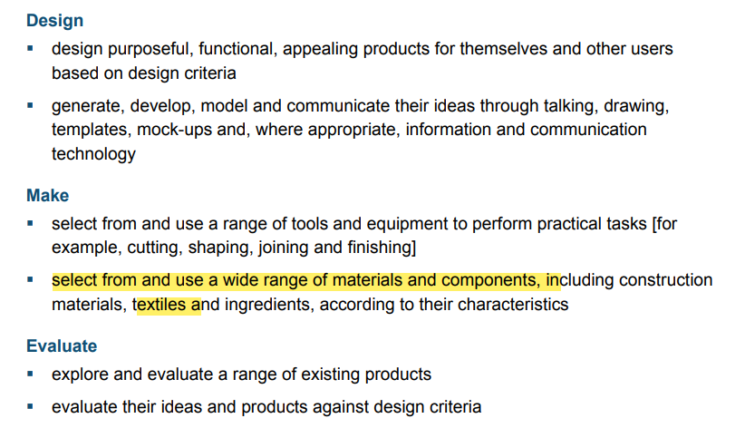 | 1. Can I explore existing puppets and investigate how they have been made?  2. Can I Join fabrics by using. running stitch, glue, staples, over sewing, tape?  3. Can I use a running stitch? (or oversewing if it is difficult).  4. Can I design a puppet with a design criteria?  5. Can I make my puppet (use skills above)?  Can I decorate fabrics with attached items e.g. buttons, beads, sequins, braids, ribbons.  6. Can I evaluate my puppet and say what I like and do not like?

