Year 1
Unit of Work | NC Expectations | Unit End Points
Autumn 2: Fire, Fire  Mechanisms- moving pictures levers and sliders  Key Vocabulary:  Moving pictures  join materials  fold  tear  cut  levers  sliders  mechanism  Research, design, make evaluate | 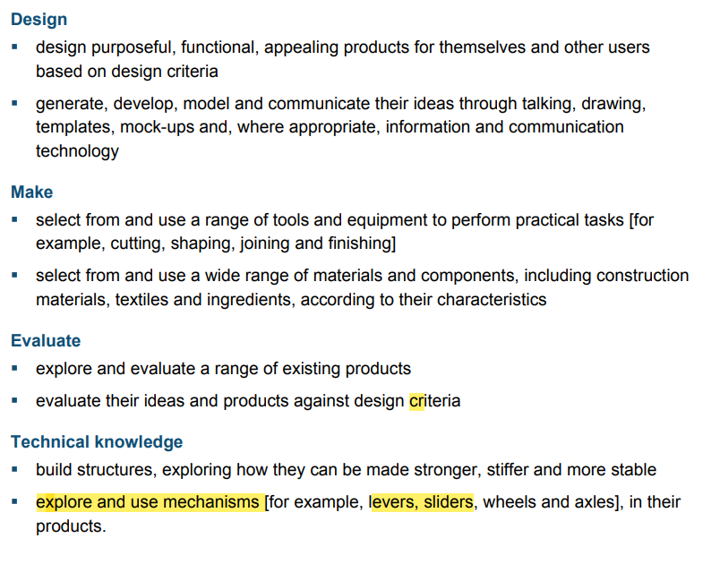 | 1.Can I ask research existing moving pictures and ask simple questions about them? (discuss mechanisms)  2.Can I cut, (use of scissors) fold and tear paper?  Can I use paper fasteners?  3.Can I explore levers and sliders to find ways of making different things move?  4.Can I design a moving pictures with a simple lever or slider?  5.Can I make my moving picture?  Can I join materials together with glue and tape?  6.Can I evaluate my design?
Spring 1-Growth and Green Fingers  Food- preparing and combing foods  Key Vocabulary:  names of fruit-chosen by teacher  kebab  skewer  assemble  ingredients  arrange  taste  smell  texture  Research, design, make evaluate | 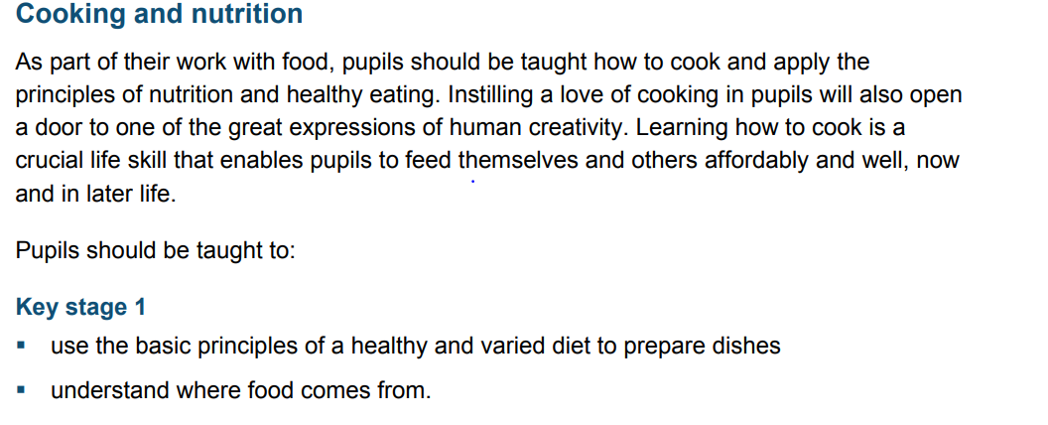 | 1. Can I explore existing products (fruit kebabs) and investigate how they have been made?  2.Can I explore a range of fruit and cut, chop, peel fruit?  3.Can I design a fruit kebab?  4.Can I make a fruit kebab (select and arrange ingredients) and communicate how it tastes?  Can I measure and weigh food items? (non-standard measures e.g. spoons, cups)  5.Can I evaluate my fruit kebab?
Summer 1 The Great Outdoors  Structures- stability and strength  Key Vocabulary:  structure  marble run  product  dowel  wood  card  stronger  stiffer  Research, design, make evaluate, improve | 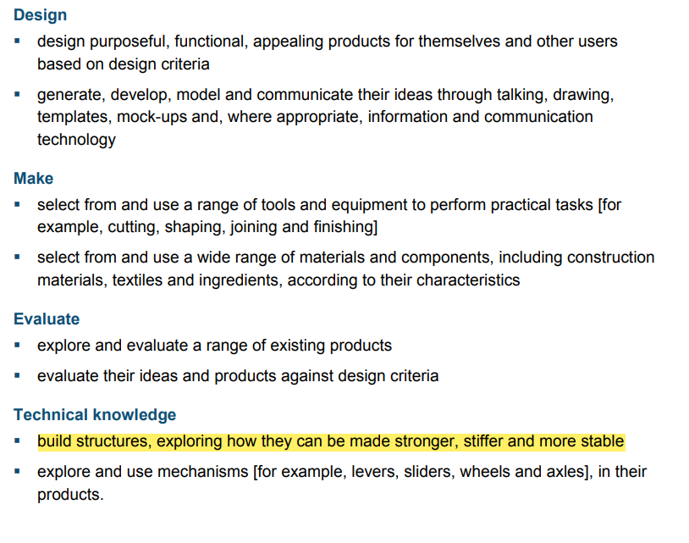 | 1. Can I research and ask simple questions about existing marble runs?  2. Can I create simple design of a marble run?  3 and 4. Can I build structures, exploring how they can be made stronger, stiffer and more stable?  Can I select and use scissors, card, glue, paper?  5.Can I evaluate my design and suggest improvements?
Summer 2 Robots  construction  robots  fastenings  design criteria  sketch  annotate | 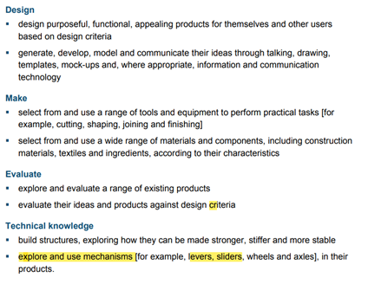 | - Can I explore making robots with different construction materials?  - Explore robotic toys f possible- through videos or real toys.  2.Can I explore different fastenings?- ▪ Children can choose from appropriate joining and fixing methods including paper fasteners, treasury tags, PVA, masking tape, glue sticks, strong carpet tape.  2.Can I design a robot with a design criteria?  3.Can I make my robot and annotate my sketch?  Children to draw and annotate a sketch of their robot as they make it.  4.Can I write how I made my robot?  *using first, next, then, after that- sequence.  5.Can I evaluate my robot?  6. Can I make changes and improve my robot?

