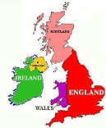  English  This term, we will be reading a range of legends of the British Isles, which will help us to plan and write a legend of our own. In addition, we will produce a formal presentation about a county within the British Isles. | 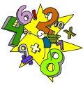  Maths  We will continue to improve our place value and times tables knowledge. In addition, we will use written methods to add and subtract. We will also cover statistics, angles and perimeter. | 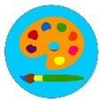  History  Our topic this term is Anglo-Saxons. We will discover who they were, where they came from and their reasons for invading England. We will produce a timeline and research what it was like to live during that period.
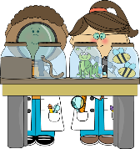  Science  This term we will be learning about the properties of materials and comparing everyday materials. We  will carry out comparative and fair tests and use the knowledge of solids, liquids and gases to decide how mixtures might be separated. | Music  We will be listening to, and performing, a range of music based on the theme of: What shall we do  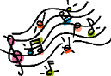  with the drunken sailor? We will look at some musical symbols and terms such as: tempo, pitch and duration. |   Computing  We will begin to simplify code to create a playable game. We will also understand what a simulation is and program a simulation using 2Code. We will then create a playable game and understand what a function is and how functions work in code.
  Geography  We will be looking at UK counties, countries, cities and key features using a range of mapping and research tools. We will focus on grid references and identify key human and physical features in a country of the UK. |   Autumn Term 1 2025  Year 5  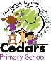 |   Physical Education  The theme this half term is project based learning and mindfulness. We will be focusing on communication, with a focus on loud and clear communication when asking for a ball from a teammate. We will also consider listening skills and try to encourage each other.
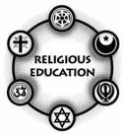  Religious Education We will be investigating the bible as a source of Christian belief. The aim of this unit will be to deepen children’s understanding of the importance and impact of the contents of the Bible in the lives of Christians. It will also develop further children’s understanding of the significance of holy books in the lives of the people of all world faiths. | General Information  We will continue to send homework home on a weekly basis on a Wednesday and would like it returned on a Monday. This will consist of a variety of English, Maths, Spellings, Times Tables and Reading activities. This will be detailed on the homework grid in the homework books. Please also access Matheletics and www.purplemash.com | 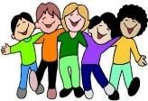  Personal, Social and Health  Education  This term we will be exploring identity and what makes us who we are. We will also look at similarities and differences between people. Identity will be discussed in relation to culture, gender, faith and ethnicity.

