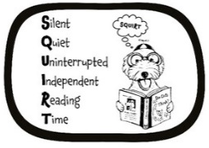

Cedars Recommended Reading Spines Text
Year Groups/Class Reading Areas

EYFS Nursery  Where’s Spot? – Eric Hill  Dear Zoo – Rod Campbell  You Choose – Pippa Goodhart and Nick Sharratt  We’re Going on a Bear Hunt – Michael Rosen  Brown Bear, Brown Bear, What Do You See? –  Bill Martin Jnr and Eric Carle  Jasper’s Beanstalk – Nick Butterworth and Mick Inkpen  The Very Hungry Caterpillar – Eric Carle  Hairy Maclary from Donaldson’s Dairy – Lynley Dodd  Each Peach Pear Plum – Allan and Janet Ahlberg  Hug – Jez Alborough  The Train Ride – June Crebbin  Come on, Daisy – Jane Simmons | 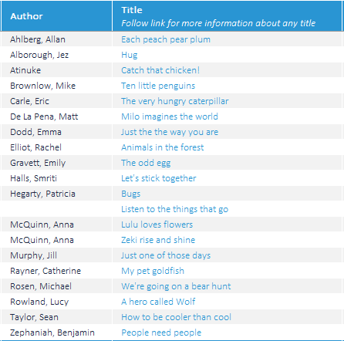
EYFS Reception  Owl Babies – Martin Waddell  The Gruffalo – Julia Donaldson  Handa’s Surprise – Eileen Browne  Mr Gumpy’s Outing – John Burningham  Rosie’s Walk – Pat Hutchins  Six Dinner Sid – Inga Moore  Mrs Armitage – Quentin Blake  Whatever Next – Jill Murphy  On the Way Home – Jill Murphy  Farmer Duck – Martin Waddell  Goodnight Moon – Margaret Wise-Brown  Shhh! – Sally Grindley | 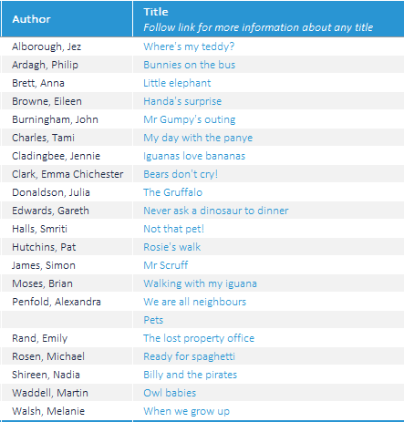
Year 1:  Peace at Last – Jill Murphy  Can’t You Sleep Little Bear? – Martin Waddell  Where the Wild Things Are – Maurice Sendak  The Elephant and the Bad Baby – Elfrida Vipont and Raymond Briggs  Avocado Baby – John Burningham  The Tiger Who Came to Tea – Judith Kerr  Lost and Found – Oliver Jeffers  Knuffle Bunny – Mo Willems  Beegu – Alexis Deacon Dogger – Shirley Hughes  Cops and Robbers – Ala | 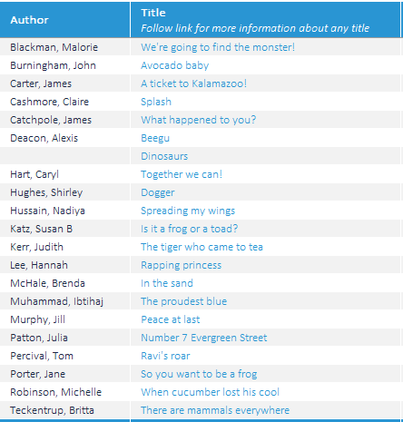
Year 2:  Traction Man is Here - Mini Grey  Meerkat Mail – Emily Gravett  Amazing Grace – Mary Hoffman  Pumpkin Soup – Helen Cooper  Who’s Afraid of the Big Bad Book? – Lauren Child  Dr Xargle’s Book of Earthlets – Tony Ross  Not Now Bernard – David McKee  Tuesday – David Wiesner  The Flower – John Light  Gorilla – Anthony Browne  Emily Brown and The Thing – Cressida Cowell  Frog and Toad Together – Arnold Lobel  The Owl Who Was Afraid of the Dark – Jill Tomlinson  Fantastic Mr Fox – Roald Dahl  The Hodgeheg – Dick King-Smith  Flat Stanley – Jeff Brown  Willa and Old Miss Annie – Berlie Doherty | 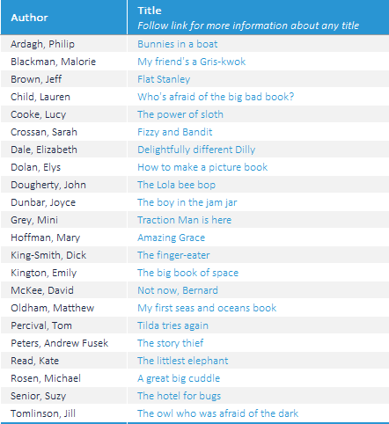
Year 3:  The Iron Man – Ted Hughes  Cat Tales: Ice Cat – Linda Newberry  The Sheep-pig – Dick King-Smith  The Abominables- Dick King-Smith  The Lion, The Witch and The Wardrobe – CS Lewis  The Battle of Bubble and Squeak | 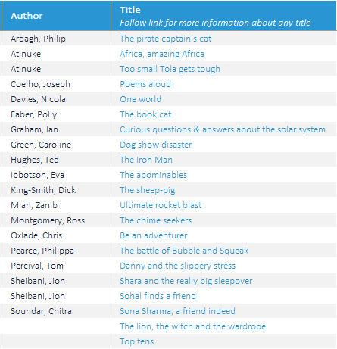
Year 4:  Bill’s New Frock – Anne Fine  Charlotte’s Web – EB White  Why the Whales Came – Michael Morpurgo  The Firework Maker’s Daughter – Phillip Pullman  The Snow Walker’s Son – Catherine Fisher  Perry Angel’s Suitcase – Glenda Millard  Voices in the Park – Anthony Browne | 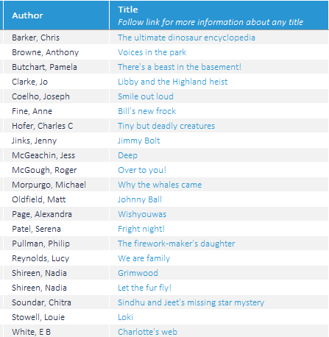
Year 5:  The Wolves of Willoughby Chase – Joan Aiken  Varjak Paw – SF Said  Wolf Brother – Michelle Paver  Street Child – Berlie Doherty  The Midnight Fox – Betsy Byars  Tom’s Midnight Garden – Phillipa Pearce  FArTHER – Grahame Baker-Smith | 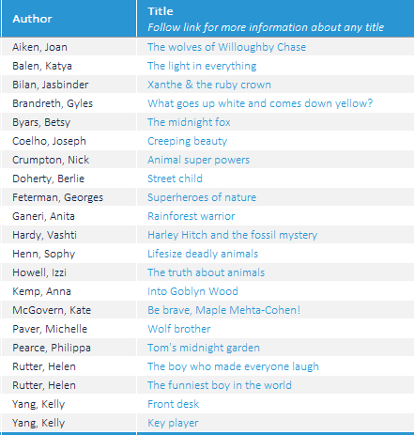
Year 6:  Holes – Louis Sachar  Clockwork – Phillip Pullman  The Hobbit – JRR Tolkien  Skellig – David Almond  Fireweed – Jill Paton Walsh  River Boy – Tim Bowler  The Arrival – Shaun Tan | 

