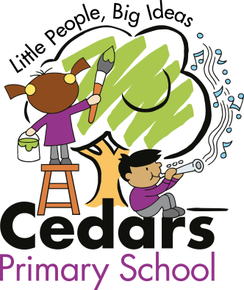
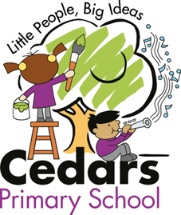

Writing Competition

To commemorate Her Majesty’s historic reign, Cedars are launching a short story writing competition. We are looking for imaginative, creative stories inspired by Her Majesty Queen Elizabeth II. The winning entries will be published in our very own Cedars’ story book and on the website.

Write your name and class on the story clearly.

A winner will be selected from each year group.
Entries must be in by 17th June 2022.
Winners will be announced on 26th June 2022.
Good Luck!
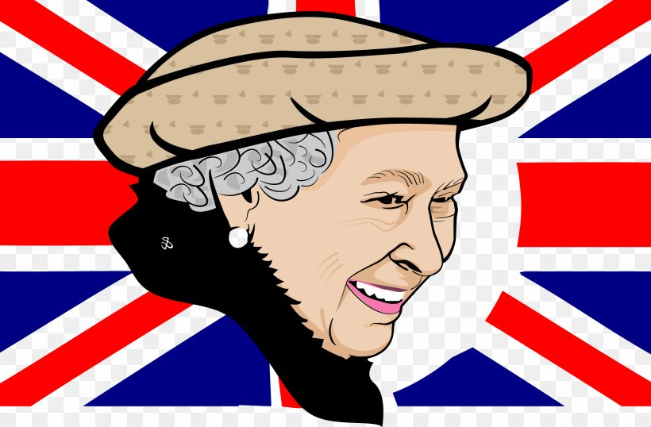

Writing Competition

To commemorate Her Majesty’s historic reign, Cedars are launching a short story writing competition. We are looking for imaginative, creative stories inspired by Her Majesty Queen Elizabeth II. The winning entries will be published in our very own Cedars’ story book and on the school website.

Write your name and class on the story clearly.

A winner will be selected from each year group.
Entries must be in by 17th June 2022.
Winners will be announced on 26th June 2022.
Good Luck!

