

MUSIC LESSONS ONLINE – AUTUMN 2020
To support your music lessons, Bolton Music Service has created online lessons that you can use if our teachers are unable to come into school to deliver them.
Here are the instructions on how to access them.

Website: https://www.gmmusiconline.co.uk/site/

Click on Pupil & Teacher Log-in
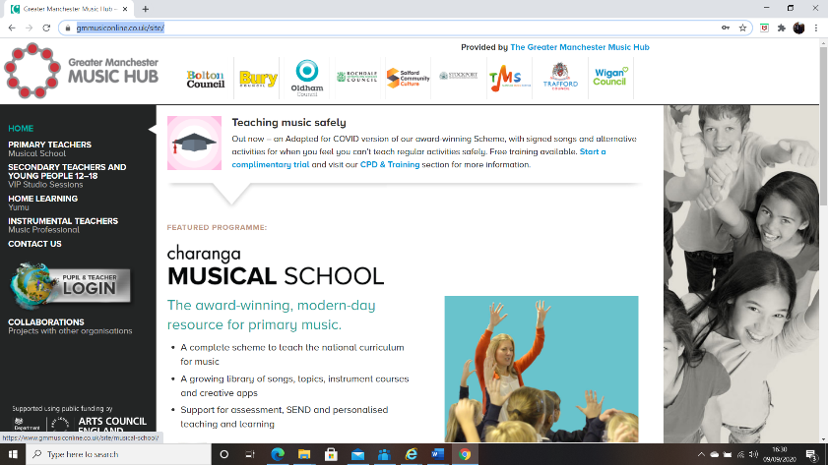

Enter your school’s Username and Password into YUMU (Student Log-in)
NB: You will have separate usernames and passwords for each of the units.
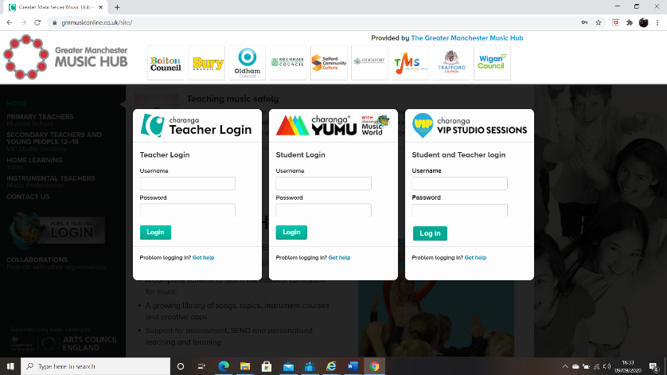

Click on the assignment
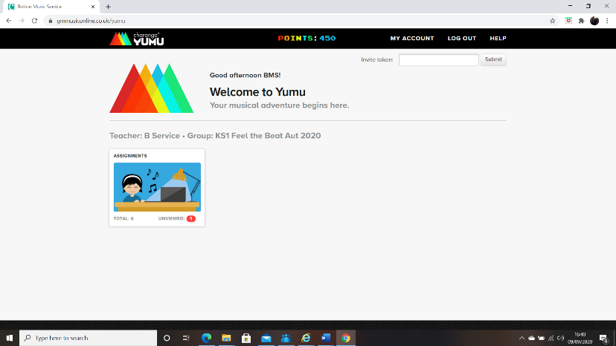

Choose the appropriate lesson

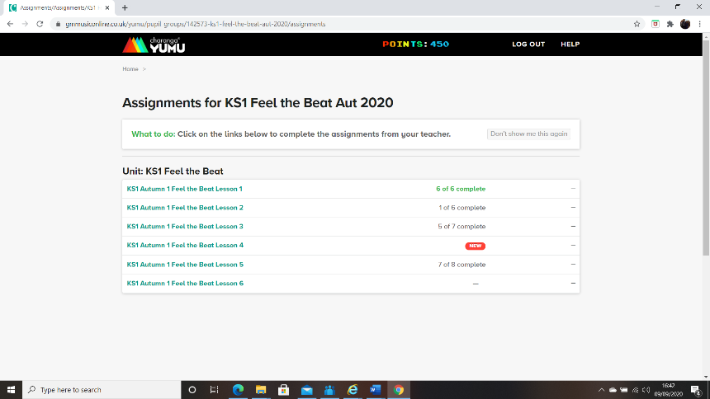

Click on each of the activities in the right hand tool bar, working through them in order. If it opens a video or audio clip you will need to click the play button. You will also find the lesson plan in the tool bar, with notes for the teacher.
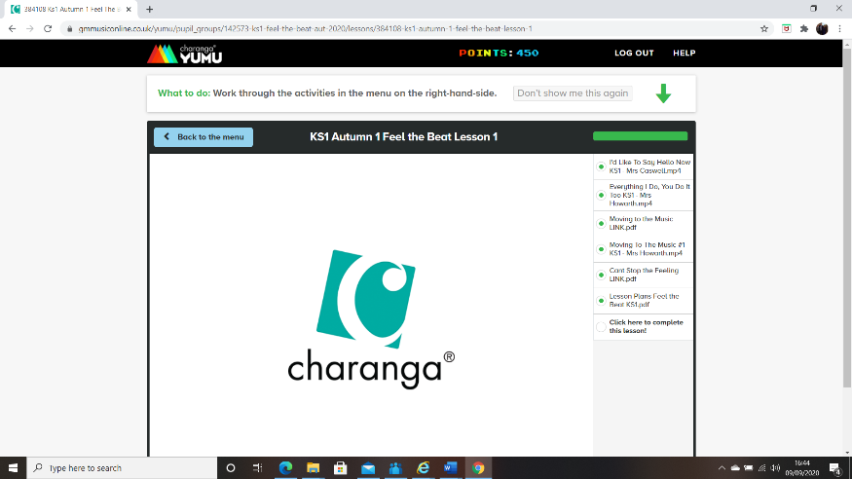

If you need any further help please contact us: music.service@bolton.gov.uk

