
Year 6 - Spring Term 2 Week 1 Homework

Home Reading | Spellings | Online Tasks |  | Topic Task
3 times per week.  Please sign the reading record book each time. It can be a mix of their reading book and books from home.. | Learn weekly spellings:  Unit 11 Plural Nouns  box boxes  party parties  bonus bonuses  address addresses  wash washes  match matches  lunch lunches  peach peaches | Mathletics   |  | Science Task – Circulatory System  Write a definition for the following words:  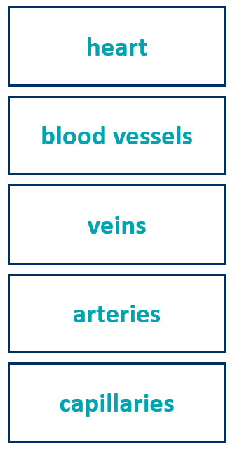
PupleMash
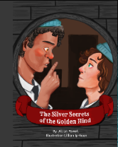
Silver Secrets of the Golden Hind
Chapter 1
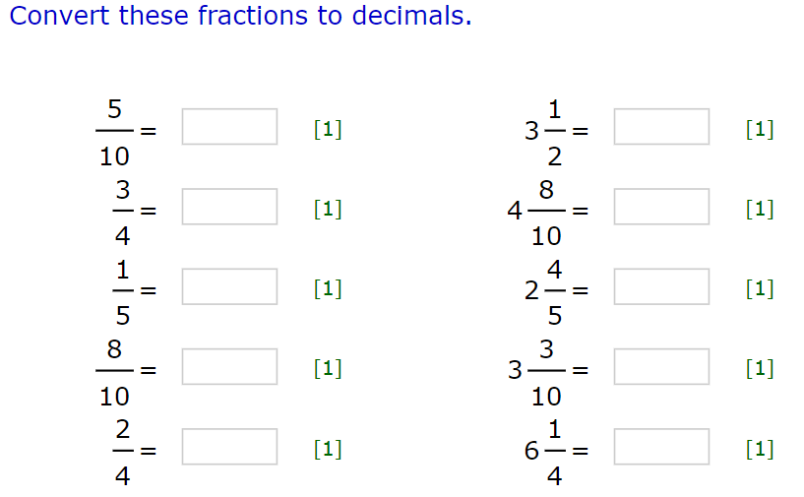
Arithmetic Skills: & Place Value
Complete in your homework book. (no calculator allowed)

Year 6 - Spring Term 2 Week 2 Homework

Home Reading | Spellings | Online Tasks |  | Topic Task
3 times per week.  Please sign the reading record book each time. It can be a mix of their reading book and books from home.   | Learn weekly spellings:  Special focus 11  Orange Words  government  conscience  twelfth  conscious  environment  parliament  shoulder  soldier | Mathletics |  | Grammar – Create a revision guide  Create a revision guide for the tenses and verb forms below:  *Present tense  *Past tense  *Present perfect  *Past perfect  *Present progressive  *Past progressive  *Passive voice  *Active voice  *Subjunctive form  *Modal verbs
PupleMash
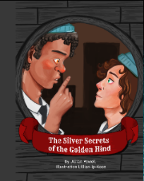
Silver Secrets of the Golden Hind
Chapter 2
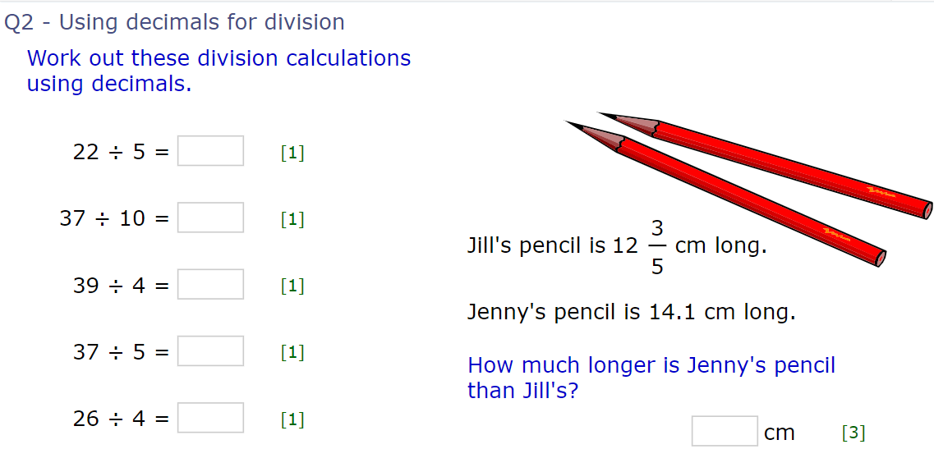
Arithmetic Skills: & Place Value
Complete in your homework book. (no calculator allowed)

Year 6 - Spring Term 2 Week 3 Homework

Home Reading | Spellings | Online Tasks |  | Topic Task
3 times per week.  Please sign the reading record book each time. It can be a mix of their reading book and books from home.. | Learn weekly spellings:  Unit 12  Plural Nouns  yourself yourselves  wolf wolves  potato potatoes  thief thieves  echo echoing  person persons  bookshelf  bookshelves  knife knives | Mathletics |  | Science – Fact file  William Harvey was the first person to correctly describe blood’s circulation in the body  Create a fact file on William Harvey
PupleMash
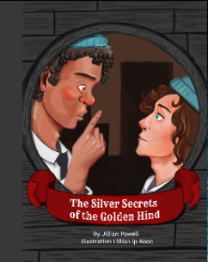
Silver Secrets of the Golden Hind
Chapter 3

Arithmetic Skills: & Place Value
Complete in your homework book. (no calculator allowed)
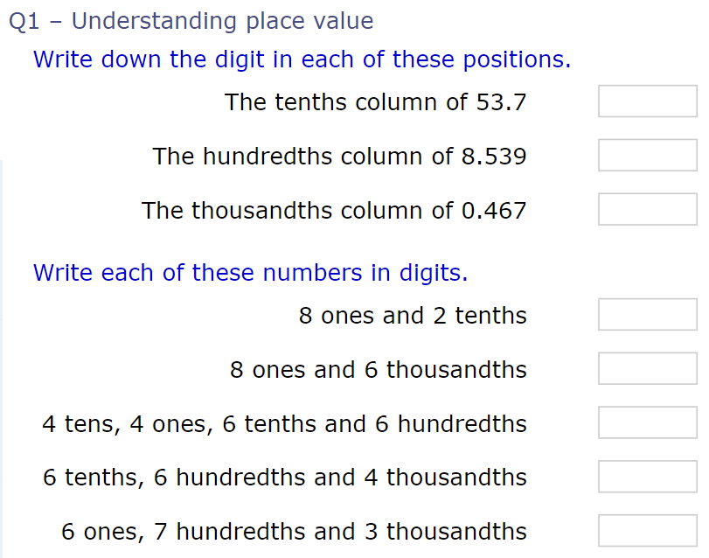

Year 6 - Spring Term 2 Week 4 Homework

Home Reading | Spellings | Online Tasks | Topic Task
3 times per week.  Please sign the reading record book each time. It can be a mix of their reading book and books from home.. | Learn weekly spellings:  Special Focus 12  Homophones  advice  advise  practise  practice  license  licence  device  devise | Mathletics | PSHE Task  Create a PowerPoint about Mental Well-being.  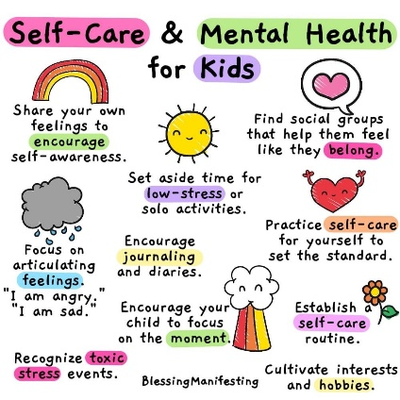  How can we can make judgements & decisions? List some ways of resisting negative peer pressure around issues affecting their health & well-being.
PupleMash
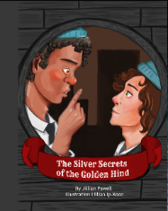
Silver Secrets of the Golden Hind
Chapter 4
SATS Companion

Complete activities set:
https://app.satscompanion.com/login

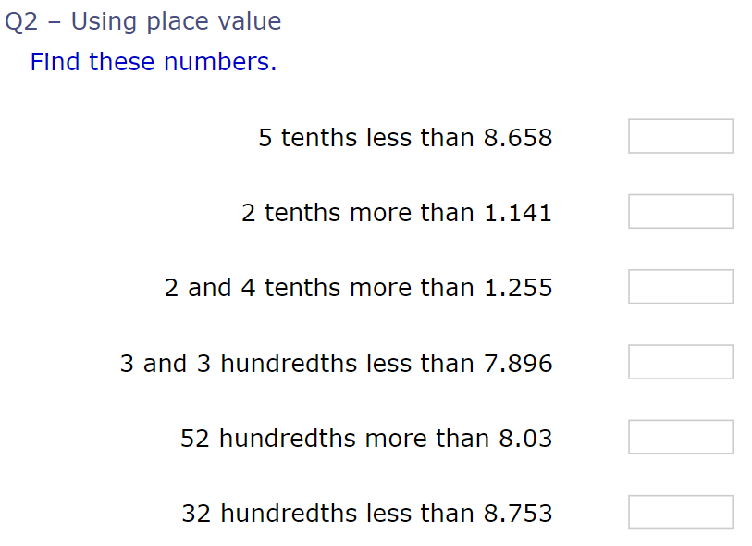
Arithmetic Skills: & Place Value
Complete in your homework book. (no calculator allowed)

Year 6 - Spring Term 2 Week 5 Homework

Home Reading | Spellings | Online Tasks | Topic Task
Home Reading  3 times per week.  Please sign the reading record book each time. It can be a mix of their reading book and books from home. | Learn weekly spellings:  Year 5 and 6  Statutory Spieling list  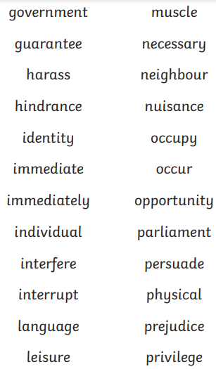 | Mathletics | Computing Task  Unit 6.5 Text Adventures  Plan your map based text adventure.  Upload images of the game and the code  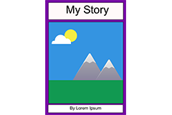  https://www.purplemash.com/#app/pup/text_adventure_planner
PupleMash
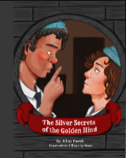
Silver Secrets of the Golden Hind
Chapter 5

Arithmetic Skills: & Place Value
Complete in your homework book. (no calculator allowed)
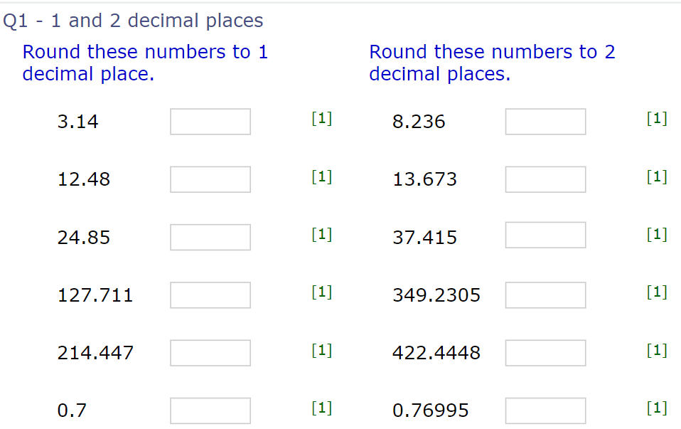

Year 6 - Spring Term 2 Week 6 Homework

Home Reading | Spellings | Online Tasks | Topic Task
Home Reading  3 times per week.  Please sign the reading record book each time. It can be a mix of their reading book and books from home. | Learn weekly spellings:  Year 5 and 6  Statutory Spieling list  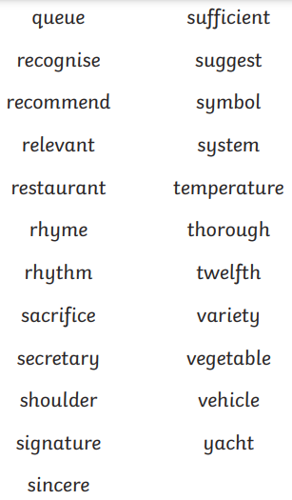 | Mathletics | French Task  C'est de quelle couleur?  (What colour is it?)  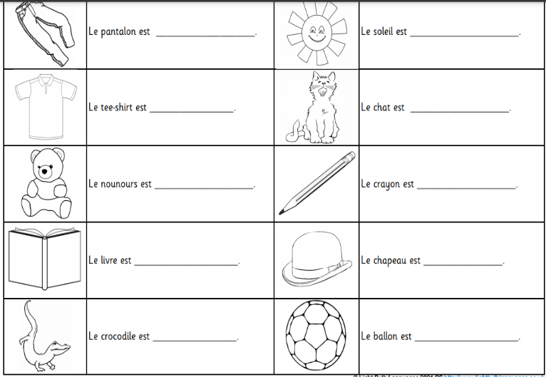  Draw and Colour in the pictures any colour you want from the list below – they do not have to be true to life.
PupleMash
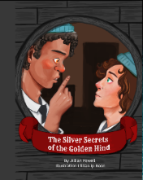
Silver Secrets of the Golden Hind
Book Review

Arithmetic Skills: & Place Value
Complete in your homework book. (no calculator allowed)
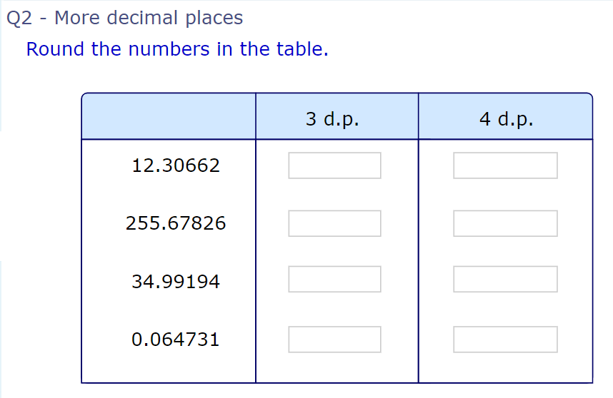

Year 6 - Spring Term 2 Easter Homework

Home Reading | Spellings | Online Tasks | Topic Task
3 times per week.  Please sign the reading record book each time. It can be a mix of their reading book and books from home. | Learn weekly spellings:  Year 5 and 6  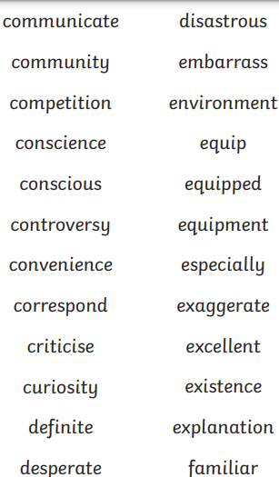  Statutory Spieling list | Mathletics | Complete Easter homework booklets
PupleMash

Silver Secrets of the Golden Hind
Character
Analysis

Arithmetic Skills: & Place Value
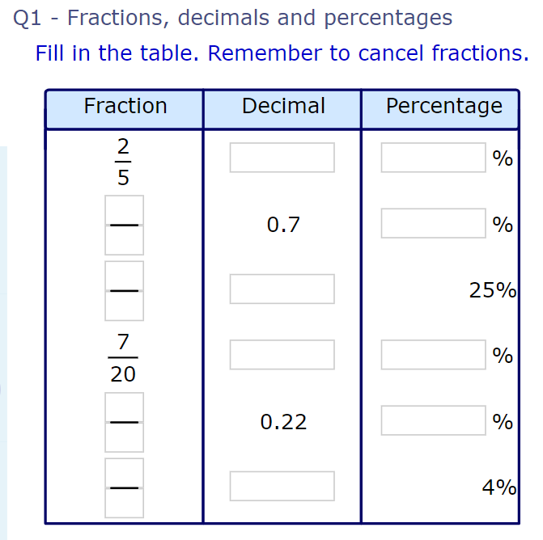
Complete in your homework book. (no calculator allowed)



