
Year 6 – Spring Term 1 Week 1 Homework

Home Reading | Spellings | Online Tasks | Topic Task
Please sign the reading record book each time you read your book.  It can be a mix of their reading book and books from home and school library.  Create a vocabulary list from your reading books include::  - Definition  - Synonyms  - Antonyms  - Prefix/suffix | Unit 8  Silent Letters  autumn  climb  guest  talk  knee  gnome  doubt  whistle  solemn  lamb | Mathletics    Complete all online activities set this week | Science  Make a periscope.  A periscope allows us to see things that are otherwise out of sight. We see an object when light coming from it enters our eyes  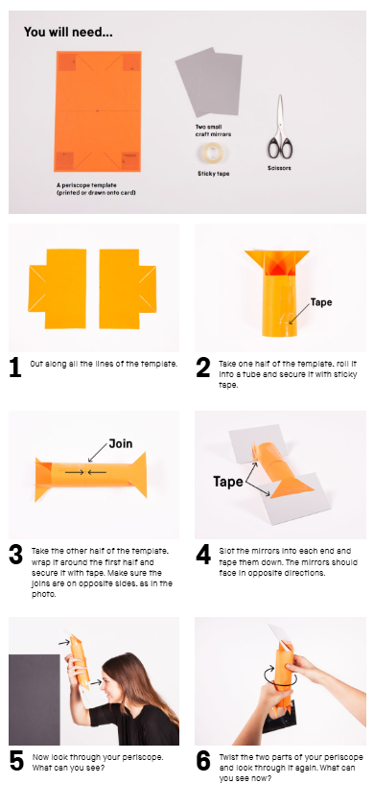  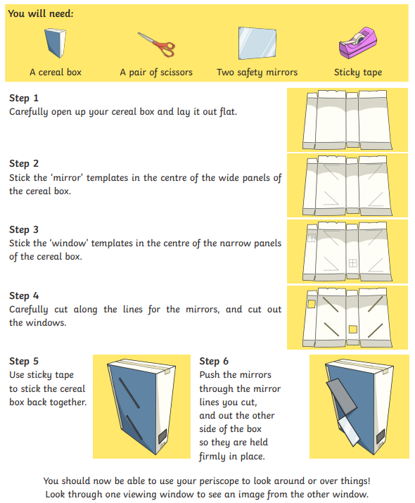
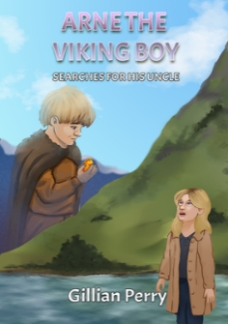
PurpleMash

Arne The Viking Boy
by Gillian Perry

Chapter 1

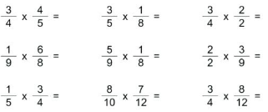
Arithmetic Skills:
Use the formal method taught to complete these calculations. Complete in your homework book.

Year 6 – Spring Term 1 Week 2 Homework

Home Reading | Spellings | Online Tasks | Topic Task
Please sign the reading record book each time you read your book.  It can be a mix of their reading book and books from home and school library.  Create a vocabulary list from your reading books include::  - Definition  - Synonyms  - Antonyms  - Prefix/suffix | Special focus 8  Orange words  available  category  existence  controversy  explanation  identity  variety  ancient | Mathletics  Complete all online activities set this week | PSHE  Dental hygiene  1. What job do incisors do? Cutting, grinding or tearing.  2. What job do molars do? Cutting, grinding or tearing.  3. What is plaque? Food residue or bacteria. How much toothpaste should you use: A pea sized, acorn sized or conker sized amount?  4. How often should you visit your dentist if you have healthy teeth?  5. How often should you brush your teeth?  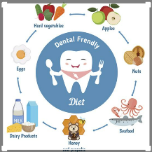
PurpleMash

Arne The Viking Boy
by Gillian Perry

Chapter 2

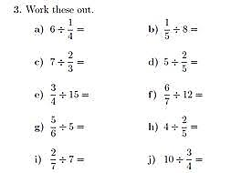
Arithmetic Skills
Use the formal method taught to complete these calculations. Complete in your homework book.

Year 6 – Spring Term 1 Week 3 Homework

Home Reading | Spellings | Online Tasks | Topic Task
Please sign the reading record book each time you read your book.  It can be a mix of their reading book and books from home and school library.  Create a vocabulary list from your reading books include::  - Definition  - Synonyms  - Antonyms  - Prefix/suffix | Unit 9  Spelling ei and ie  piece  perceive  relief  deceive  achieve  ceiling  receive  niece | Mathletics  Complete all online activities set this week | DT  Design a healthy meal for a primary school child thinking about health and nutrition.  Use the Eatwell plate on the knowledge organiser to help you.  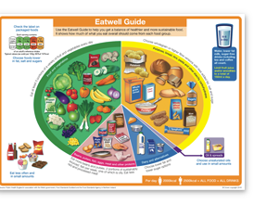
PurpleMash

Arne The Viking Boy
by Gillian Perry

Chapter 3/4

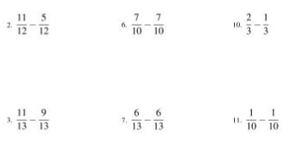
Arithmetic Skills
Use the formal method taught to complete these calculations. Complete in your homework book.

Year 6 – Spring Term 1 Week 4 Homework

Home Reading | Spellings | Online Tasks |  | Topic Task
Please sign the reading record book each time you read your book.  It can be a mix of their reading book and books from home and school library.  Create a vocabulary list from your reading books include::  - Definition  - Synonyms  - Antonyms  - Prefix/suffix | Special Focus 9  hyphens  co-operate  re-enter  re-open  co-ordinate  co-own  co-operation  re-explain  re-energise | Mathletics  Complete all online activities set this week |  | PE  Create your own team game. Think about:  - Rules  - Number of players  - Equipment  - Attackers  Defenders  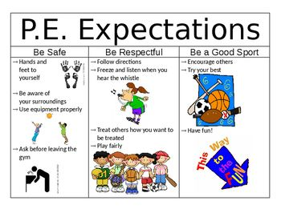
PurpleMash

Arne The Viking Boy
by Gillian Perry

Chapter 5/6

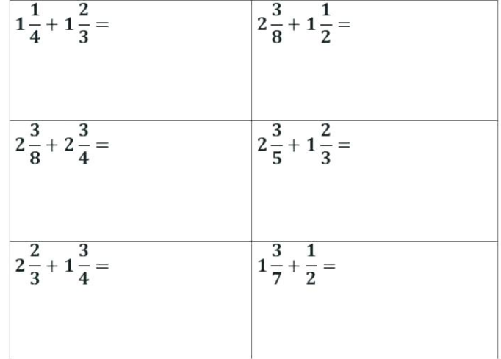
Arithmetic Skills: & Place Value
Complete in your homework book. (no calculator allowed)

Year 6 – Spring Term 1 Week 5 Homework

Home Reading | Spellings | Online Tasks |  | Topic Task
Please sign the reading record book each time you read your book.  It can be a mix of their reading book and books from home and school library.  Create a vocabulary list from your reading books include::  - Definition  - Synonyms  - Antonyms  - Prefix/suffix | Unit 10  ible able  comfortable  responsible  adorable  reliable  considerable  suitable  terrible  understandable  visible | Mathletics  Complete all online activities set this week |  | History  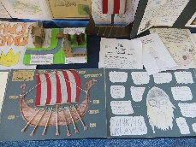  Draw, paint or create a poster or fact-file about a Viking God or Goddess. Anglo Saxons and Vikings were fierce warriors. Research and make a weapon that they typical used in battle.  Look at images of Anglo Saxon coins and design or make your own.
PurpleMash

Arne The Viking Boy
by Gillian Perry

Chapter 7

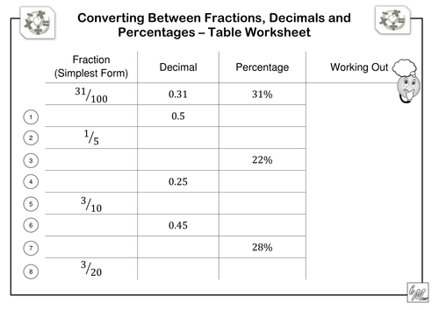
Arithmetic Skills: & Place Value
Use the formal method taught to complete these calculations. Complete in your homework book.

Year 6 – Spring Term 1 Week 6 Homework

Home Reading | Spellings | Online Tasks |  | Topic Task
Please sign the reading record book each time you read your book.  It can be a mix of their reading book and books from home and school library.  Create a vocabulary list from your reading books include::  - Definition  - Synonyms  - Antonyms  - Prefix/suffix | Special Focus 10  Common mistakes  whose who’s  its it’s  your you’re  theirs there’s | Mathletics  Complete all online activities set this week |  | RE –  Exodus  How do you know you belong?  What is good about taking part?  How do you remember special people, places and events?  How do believers show that other people matter?  
PurpleMash

Arne The Viking Boy
by Gillian Perry

Review

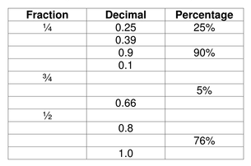
Arithmetic Skills: & Place Value
Use the formal method taught to complete these calculations. Complete in your homework book.

