Year 5 Homework SPRING 1 - Topic: EARTHLINGS
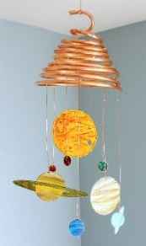
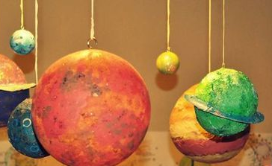
Week 1 - Holiday Project: Design and make a Space themed craft. It could be a hanging decoration, model, picture or painting.
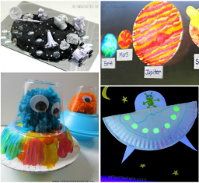


  Date Due | Activity 1  HOME READING |   Activity 2 -  SPELLINGS Write X3 and learn. |   Activity 3-  MATHS |   Activity 4-  TOPIC
WEEK 2 | Please read every night making sure that the reading record book is signed and a comment is added by a grown up. Remember: your reading book is a treasure chest containing lots of quality vocabulary and sentences. It is always a great idea to transfer some of the quality vocabulary from your reading book into your reading record. Remember to bring your reading book and record into school every day! | Recap Unit 1 and 2 words:  doubt, numb, crumb, tomb, thumb, debt, climb, subtle, bomb, comb, limb, lamb,  credible, visible, possible, legible, responsible, horrible, edible, reversible, sensible, resistible | Calculations: Addition  10235 + 4231  78972 + 65217  7481 + 1232  451.25 + 212.79  81.65 + 84.31  898.36 + 123.8  178.6 + 0.254 | French –  Write the days of the week in French and the numbers to 20 in French. Learn to say them in a fluent French accent!
WEEK 3 |  | Recap Unit 3 words:  Bearable, enjoyable, reasonable, believable, suitable, enviable, knowledgeable, noticeable, changeable, adaptable, breakable, reliable, beatable, predictable, understandable, comfortable, adorable, miserable | Calculations: squared and cubed  3² + 4² 9² + 4³  5³ + 5² 7² + 6²  10² + 10³ 3² + 3³ | Science-Create a model or a poster of the solar system including all the planets– be as creative as you can. How will you show the different sizes of the planet?
WEEK 4 |  | Recap Unit 4 words:  nestle, castle, whistle, jostle, soften, glisten, bustle, hustle, rustle, wrestle, listen, hasten, fasten | Calculations: divide  2142÷9 1663÷3 3751 ÷ 6 1026÷7 1879÷6 4210 ÷ 8  Challenge: Write the remainders as decimals. | Art- choose your favourite work of Peter Thorpe. Replicate the work using the equipment you have at home.
WEEK 5 |  | Learn Unit 5 words:  Understandably, suitably, comfortably, miserably, horribly, terribly, incredibly, possibly, responsibly, reasonably, adorably, considerably, visibly | Calculations: subtract  10800–238 20177-10232  989.37-32.21 89.14–58.79  963.71 – 211.21 120.41 – 14.32  Challenge: Write the inverse for each calculation. | Science- Research one planet of your choice. Create an attractive fact file.
WEEK 6 |  | Learn Unit 6 words:  Frequent, patient, ancient, innocent, dependent, intelligent, obedient, magnificent, violent, silent, efficient, urgent, different | Create a poster for our Maths area about angles and their properties. Use the words: acute, obtuse, rught, reflex and straight line. | Music- Find the lyrics for Madina tun Nabi, which is a catchy modern Islamic song. Write one of the verses in your book using your best handwriting. Memorise it.

