Year 5 Homework Autumn 2- Topic: Food Glorious Food
Date Due |   Activity 1  HOME READING | Activity 2  SPELLINGS Write three times and learn. |   Activity 3  MATHS |   Activity 4  TOPIC
WEEK 1 | Please read every night making sure that the reading record book is signed and a comment is added by a grown up. Remember: your reading book is a treasure chest containing lots of quality vocabulary and sentences. It is always a great idea to transfer some of the quality vocabulary from your reading book into your reading record. Remember to bring your reading book and record into school every day! | accompany  according  appreciative  aggressive  accommodate  attached | 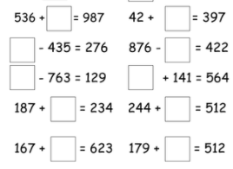 | Geography  Find 6 countries located in the Northern hemisphere of the world and 6 countries located in the southern hemisphere.
WEEK 2 |  | fasten  listen  glisten  castle  soften  hustle | Research: How many days are there in each month of the year?  Challenge: How many months are there in:  8 years and 4 months  11 years and 3 months  3 years and 5 months | Science  Research the scientist Ruth Benerito. Who was she? How did she contribute to the world of science?
WEEK 3 |  | bustle  jostle  whistle  rustle  nestle  bustled  wrestler | 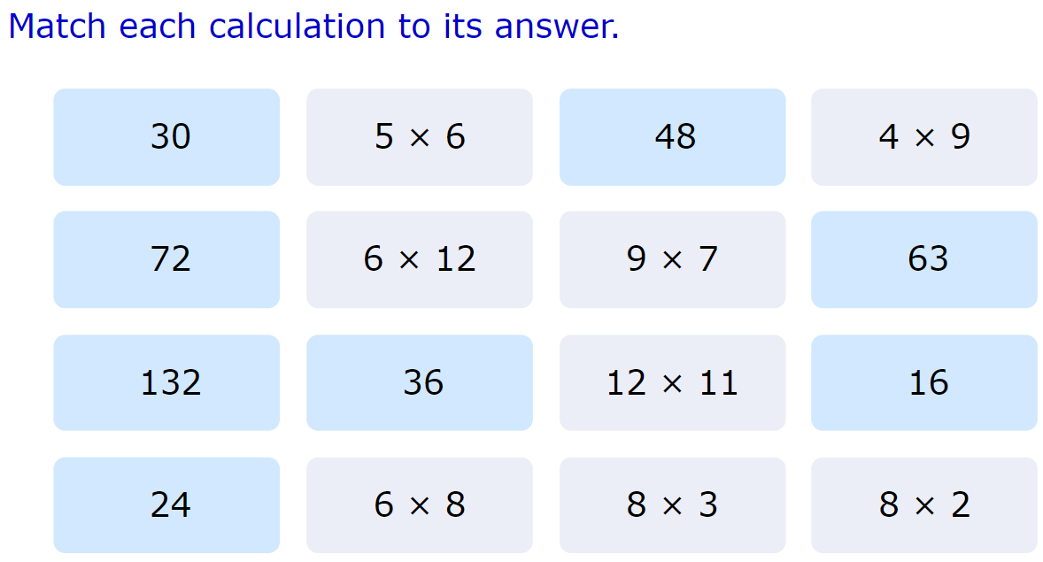  Challenge: write the inverse of each calculation. | PSHE/History  Research Remembrance Day. Write an information report about it. What is it? How is it marked? What events happen on this day?
WEEK 4 |  | understandable  suitable  comfortable  miserable  horrible | 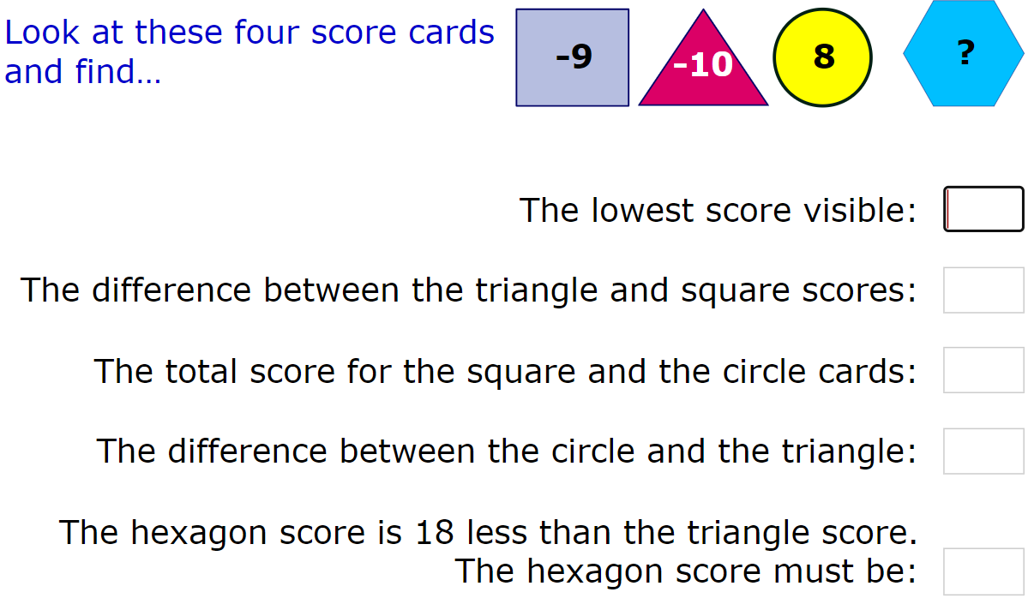 | RE  Write The Christmas Nativity Story. Don’t forget quality language and vocabulary.
WEEK 5 |  | understandably  suitably  comfortably  miserably | 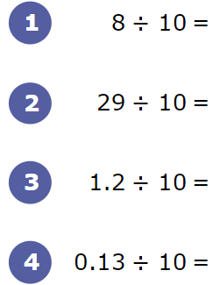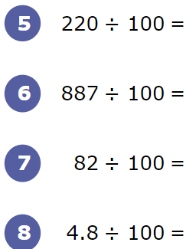  Challenge: write the inverse of each calculation | Science  Research the scientist Spencer Silver. Who was he? How did he contribute to the world of science?
WEEK 6 |  | allowed  aloud  guessed  guest  passed  past | 2546 X 1 2145 X 3  6587 X 7 4152 X 2  9877 X 3 3254 X 3  9632 X 5 1414 X 4  Challenge: write the inverse of each calculation. | French  Write 5 food nouns and 5 animal nouns in French.
WEEK 7 |  | frequent  patient  ancient  innocent  dependent  intelligent  obedient | Write all the square numbers between 0-100. | Science  Write the definitions:  Solid Transparent  Permeable Soluble Magnetic Opaque  Transluscent

