
Year 6 – Autumn Term 2 Week 1 Homework

Home Reading | Spellings | Online Tasks | Topic Task
Please sign the reading record book each time you read your book.  It can be a mix of their reading book and books from home and school library.  Create a vocabulary list from your reading books include::  - Definition  - Synonyms  - Antonyms  - Prefix/suffix | Suffixes  When we do not change the root word when a suffix beginning with a vowel is added.  Unit 5  happily  copying  mysterious  heavier  spying  applied  beautiful | Mathletics   | Science  We will be learning about fossils.  Create a fact file of the palaeontologist Mary Anning, who we studied last term.
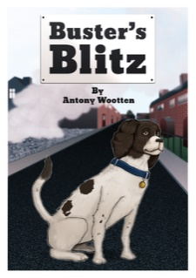
PurpleMash

Buster's Blitz
by Antony Wootten
Chapter 1
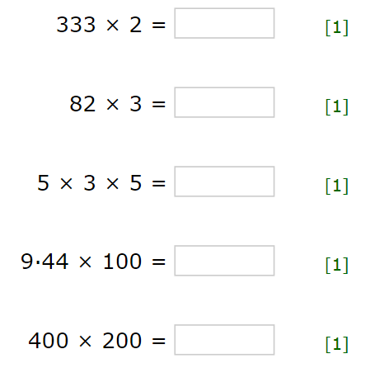
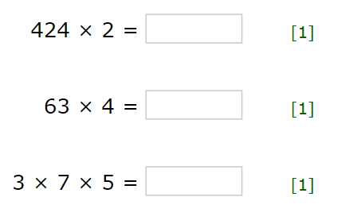
Arithmetic Skills:
Use the formal method taught to complete these calculations. Complete in your homework book.

Year 6 – Autumn Term 2 Week 2 Homework

Home Reading | Spellings | Online Tasks | Topic Task
Please sign the reading record book each time you read your book.  It can be a mix of their reading book and books from home and school library.  Create a vocabulary list from your reading books include::  - Definition  - Synonyms  - Antonyms  - Prefix/suffix | Special focus 5  Orange words  guarantee  queue  vehicle  mischievous  foreign  bargain  amateur  hindrance | Mathletics | History  Create a story box/diorama about WW2 – air raid shelters.  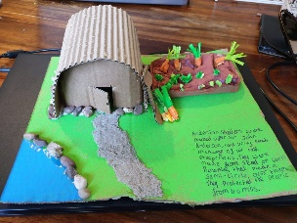  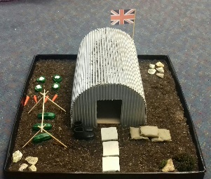
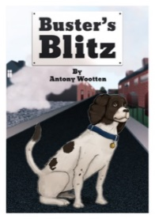
PurpleMash

Buster's Blitz
by Antony Wootten
Chapter 2

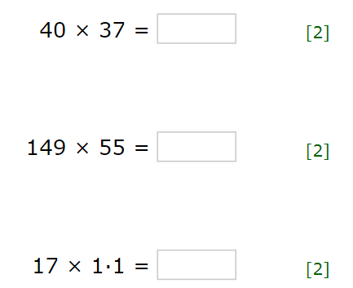
Arithmetic Skills
Use the formal method taught to complete these calculations. Complete in your homework book.

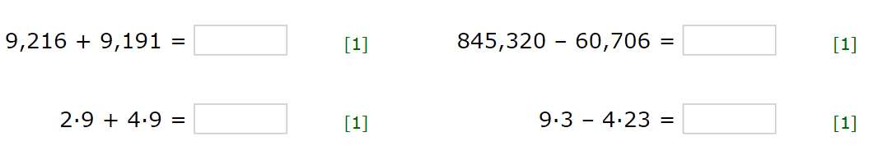
Year 6 – Autumn Term 2 Week 3 Homework

Home Reading | Spellings | Online Tasks | Topic Task
Please sign the reading record book each time you read your book.  It can be a mix of their reading book and books from home and school library.  Create a vocabulary list from your reading books include::  - Definition  - Synonyms  - Antonyms  - Prefix/suffix | Suffixes  Unit 6  Adding the sh sound ti ci  international  misdirection  reinfection  antisocial  miscalculation  subtraction  spacious | Mathletics | History  We have really enjoyed learning about WW2 this term. We have learnt all about evacuation, rationing, The Blitz, British and German Vehicles used during WW2, Propaganda posters, D-day, VE-day and Anne Frank.  Create a poster on propaganda r tasted some delicious recipes from 1940’s..  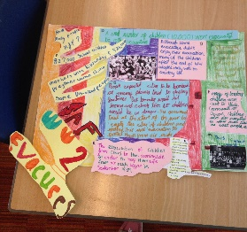
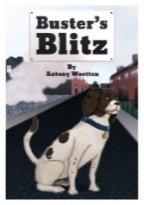
PurpleMash

Buster's Blitz
by Antony Wootten
Chapter 3
Arithmetic Skills
Use the formal method taught to complete these calculations. Complete in your homework book.
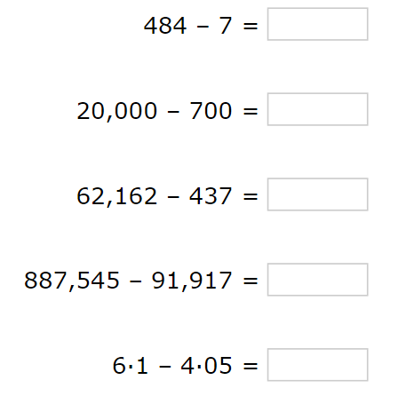
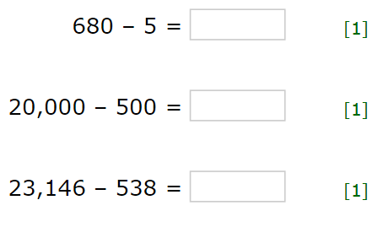

Year 6 – Autumn Term 2 Week 4 Homework

Home Reading | Spellings | Online Tasks |  | Topic Task
Please sign the reading record book each time you read your book.  It can be a mix of their reading book and books from home and school library.  Create a vocabulary list from your reading books include::  - Definition  - Synonyms  - Antonyms  - Prefix/suffix | Special Focus 6  Orange words:  homophones  morning  mourning  compliment  complement  assent  ascent  draft  draught | Mathletics |  | Music & PSHE  Listen to the song Imagine by  John Lennon  What do you think the song is about?  Write a poem or song on the same theme.  Using Lune Poem strategy  5 lines  3 lines  5 lines  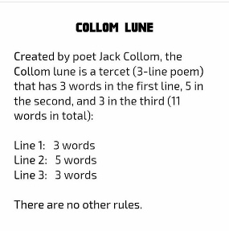

PurpleMash

Buster's Blitz
by Antony Wootten
Chapter 4

Arithmetic Skills: & Place Value
Complete in your homework book. (no calculator allowed)

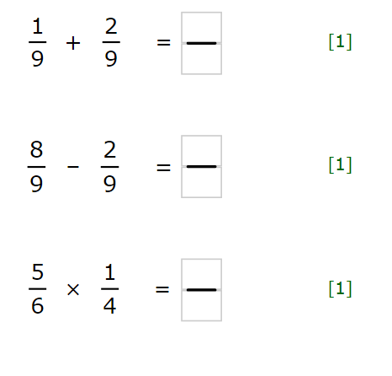
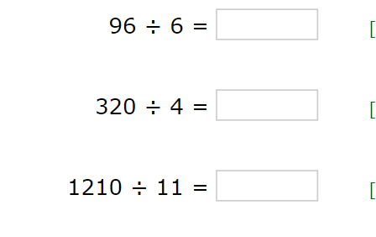

Year 6 – Autumn Term 2 Week 5 Homework

Home Reading | Spellings | Online Tasks |  | Topic Task
Please sign the reading record book each time you read your book.  It can be a mix of their reading book and books from home and school library.  Create a vocabulary list from your reading books include::  - Definition  - Synonyms  - Antonyms  - Prefix/suffix | Suffixes  Sh sound spelt si or ssi  Unit 7  expansion  comprehension  tension  permission  admission  profession  possession | Mathletics |  | Art & Design  Research the artist Wassily Kandinsky.  Write a detailed report about the artist.    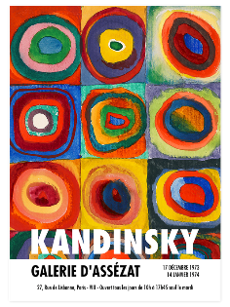

PurpleMash

Buster's Blitz
by Antony Wootten
Chapter 5

Arithmetic Skills: & Place Value

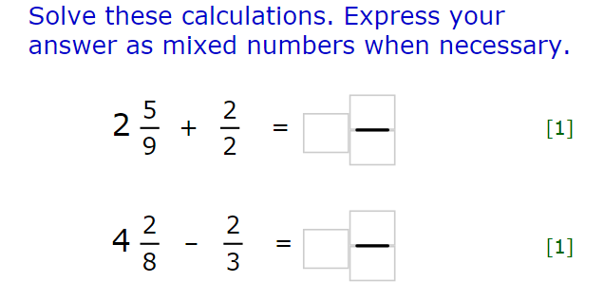
Use the formal method taught to complete these calculations. Complete in your homework book.

Year 6 – Autumn Term 2 Week 6 Homework

Home Reading | Spellings | Online Tasks |  | Topic Task
Please sign the reading record book each time you read your book.  It can be a mix of their reading book and books from home and school library.  Create a vocabulary list from your reading books include::  - Definition  - Synonyms  - Antonyms  - Prefix/suffix | Special Focus 7  Orange words  leisure  language  privilege  restaurant  achieve  secretary  stomach  yacht  soldier  physical | Mathletics |  | English & Music  Ian Fleming wrote the classic story, Chitty, Chitty Bang Bang.  Research the author and write a short biographical piece on him.  

PurpleMash

Buster's Blitz
by Antony Wootten
Chapter 6
Arithmetic Skills: & Place Value
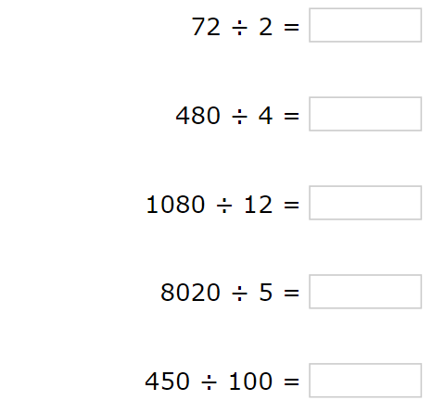
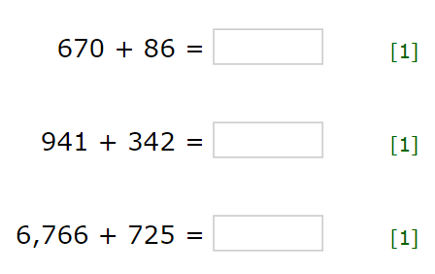
Use the formal method taught to complete these calculations. Complete in your homework book.

Year 6 – Autumn Term 2 Week 7 Homework

Home Reading | Spellings | Online Tasks |  | Topic Task
Please sign the reading record book each time you read your book.  It can be a mix of their reading book and books from home and school library.  Create a vocabulary list from your reading books include::  - Definition  - Synonyms  - Antonyms  - Prefix/suffix | Suffixes  Unit 8  Silent letters  calm  autumn  climb  guest  half  doubt  whistle | Mathletics |  | Music  Listen to the song What makes you beautiful by One Direction and Boyce Avenue.  https://www.youtube.com/watch?v=QJO3ROT-A4E  https://www.youtube.com/watch?v=K0czg_TQAcA  You are a judge on the X Factor!  Which artist would you vote for? Why? Explain in detail, use your senses to answer.  Are you choosing your favourite or most recognisable group?  
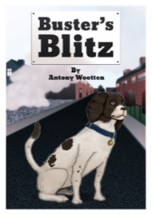
PurpleMash

Buster's Blitz
by Antony Wootten
Chapter 7

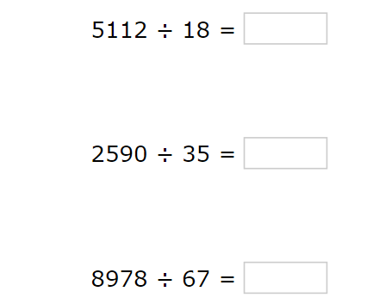
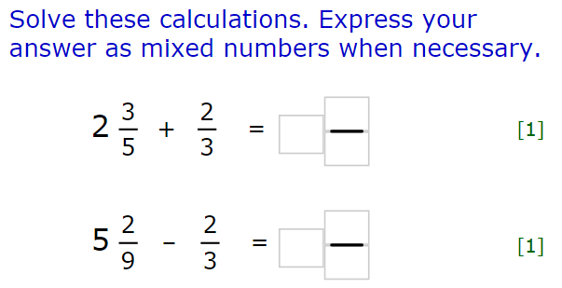
Arithmetic Skills: & Place Value
Complete using the link below. Ask for the three-word code.



