
Year 6 – Summer Term 2 Week 1 Homework

Home Reading | Spellings | Online Tasks | Topic Task
Please sign the reading record book each time you read your book.  It can be a mix of their reading book and books from home and school library.  Create a vocabulary list from your reading books include::  - Definition  - Synonyms  - Antonyms  - Prefix/suffix | Learn weekly spellings:  disorderly  ghastly  wrinkly  dastardly  leisurely  spritely  heavenly  unlikely  comply  melancholy | PurpleMash  Comprehension    Chapter 1 | French  Purple Mash - drag the objects onto the stage to create your own musical tune!  The words are:  Bonjour Marc.  Bonjour Jean.  Comment vas-tu?  Je vais bien, je vais bien, et toi?  Pas mal.  Bonjour Fleur.  Bonjour Claire.  Comment vas-tu?  Je vais bien, je vais bien, et toi?  Pas mal.    https://www.purplemash.com/#app/folder/French_La_Famille_Bonjour


Problem Solving Challenges
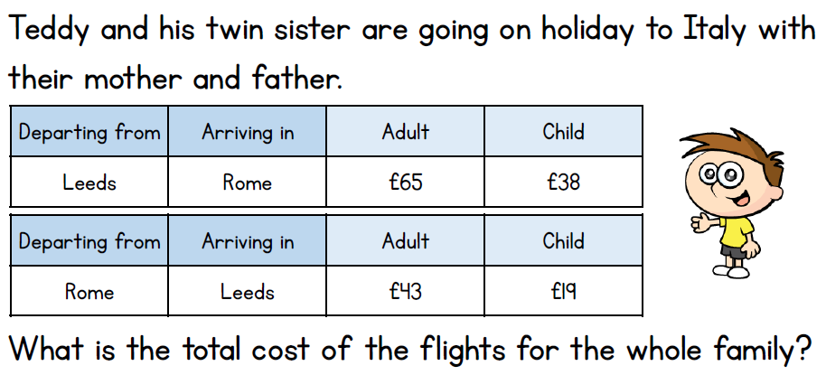

Year 6 – Summer 2 Week 2 Homework

Home Reading | Spellings | Online Tasks | Topic Task
Please sign the reading record book each time you read your book.  It can be a mix of their reading book and books from home and school library.  Create a vocabulary list from your reading books include::  - Definition  - Synonyms  - Antonyms  - Prefix/suffix | Learn weekly spellings:  observant  expectant  hesitant  tolerant  triumphant  dominant  contestant  defiant  decongestant  relevant | PurpleMash  Comprehension  Chapter 2 | Art & Design  Make drawings of the sea, seaside, lighthouses, boats, from photographs and website images. Experiment using a range of pencils, charcoal and chalk, biros and felt pens, pastels and oil pastels.  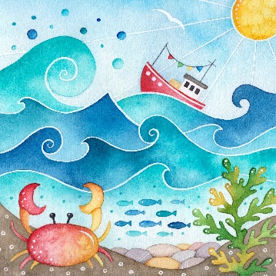
 |  | Problem Solving Challenges


Year 6 – Summer 2 Week 3 Homework

Home Reading | Spellings | Online Tasks | Topic Task
Please sign the reading record book each time you read your book.  It can be a mix of their reading book and books from home and school library.  Create a vocabulary list from your reading books include::  - Definition  - Synonyms  - Antonyms  - Prefix/suffix | Learn weekly spellings:  vegetable  symbol  sincerely  pronunciation  interfere  committee  apparent  desperate  curiosity  persuade | PurpleMash  Comprehension  Chapter 3 | History  Through the Decades      Create a collage or poster about events, memories and key events and moments of the different years 1900 - 2000
 |  | Problem Solving Challenges
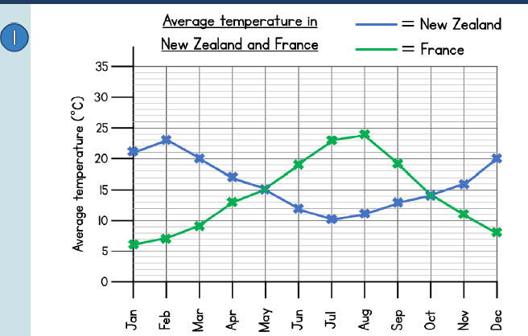
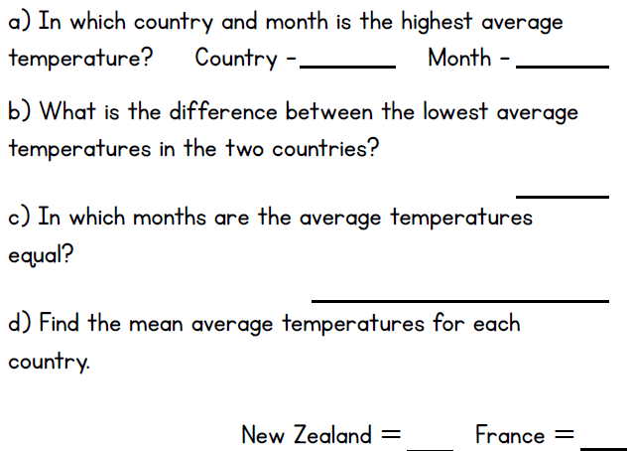

Year 6 – Summer Term 2 Week 4 Homework

Home Reading | Spellings | Online Tasks |  | Topic Task
Please sign the reading record book each time you read your book.  It can be a mix of their reading book and books from home and school library.  Create a vocabulary list from your reading books include::  - Definition  - Synonyms  - Antonyms  - Prefix/suffix | Learn weekly spellings:  identity  immediate  immediately  individual  interfere  interrupt  language  leisure  lightning  marvellous  mischievous  muscle  necessary | PurpleMash  Comprehension  Chapter 4 |  | PSHE  Transition to secondary school;  An activity to help you understand a school timetable.  Read about Jade's journey.  https://www.purplemash.com/#tab/pm-home/topics/transition    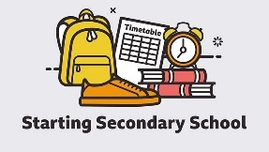
 |  | Problem Solving Challenges
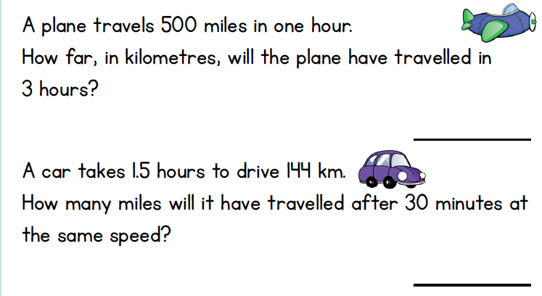
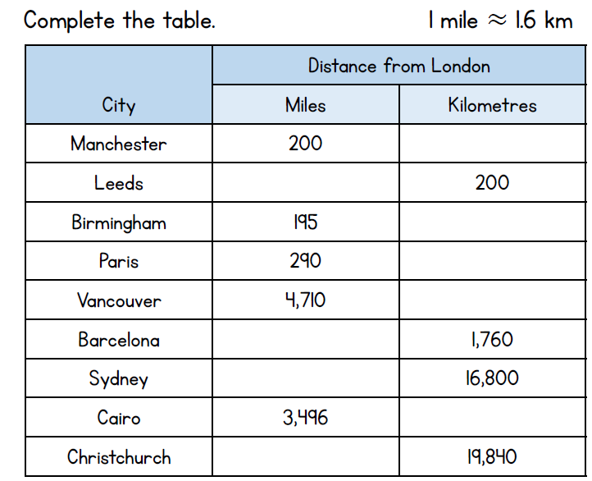

Year 6 - Summer Term 2 Week 5 Homework

Home Reading | Spellings | Online Tasks |  | Topic Task
Please sign the reading record book each time you read your book.  It can be a mix of their reading book and books from home and school library.  Create a vocabulary list from your reading books include::  - Definition  - Synonyms  - Antonyms  - Prefix/suffix | Learn weekly spellings:  neighbour  nuisance  occupy  occur  opportunity  parliament  persuade  physical  prejudice  privilege  profession  programme  pronunciation | PurpleMash  Comprehension  Chapter 5 |  | Computing  Using Technology to improve lives  Write about how information systems can help to improve people's lives.  For example, how technology can be used to assist people with no sight.  https://www.purplemash.com/#tab/pm-home/computing    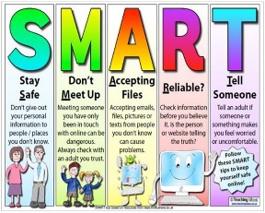
 |  | Problem Solving Challenges
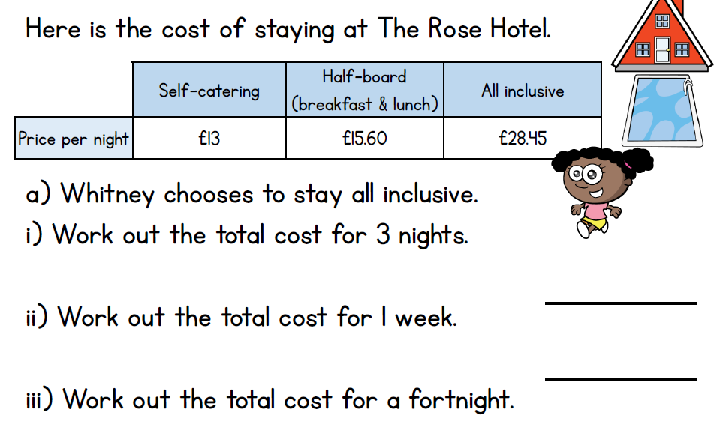

Year 6 – Summer Term 2 Week 6 Homework

Home Reading | Spellings | Online Tasks |  | Topic Task
Please sign the reading record book each time you read your book.  It can be a mix of their reading book and books from home and school library.  Create a vocabulary list from your reading books include::  - Definition  - Synonyms  - Antonyms  - Prefix/suffix | Learn weekly spellings:  queue  recognise  recommend  relevant  restaurant  rhyme  rhythm  sacrifice  secretary  shoulder  signature  sincere  sincerely | PurpleMash  Comprehension  Chapter 6 |  | PSHE  Purple Mash  Transition to secondary school;  Create a booklet about moving to your new secondary school  experience and then complete the 'Getting Prepared' frame.  https://www.purplemash.com/#tab/pm-home/topics/transition  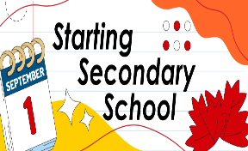
 |  | Problem Solving Challenges


